Ansible by abshiske day 24

https://github.com/iam-veeramalla/ansible-zero-to-hero

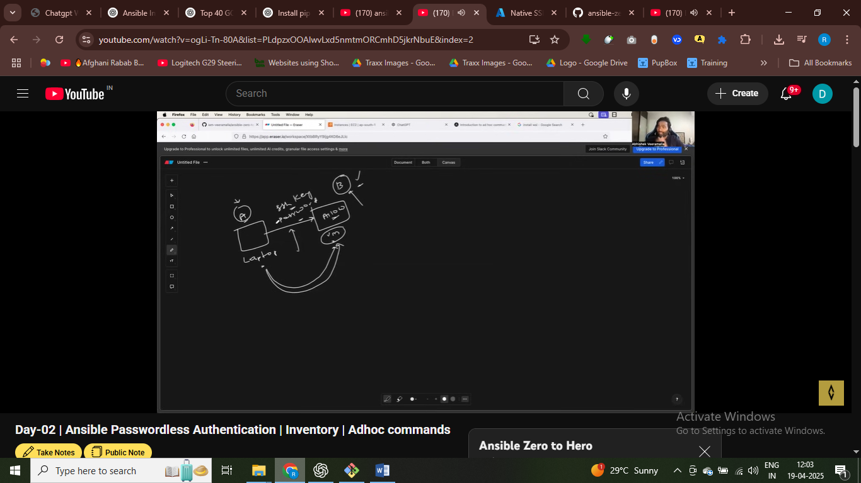

Password less atuht

Vm a get easily connect via vm b – without authenticaton – never asked for password for virtual machine A

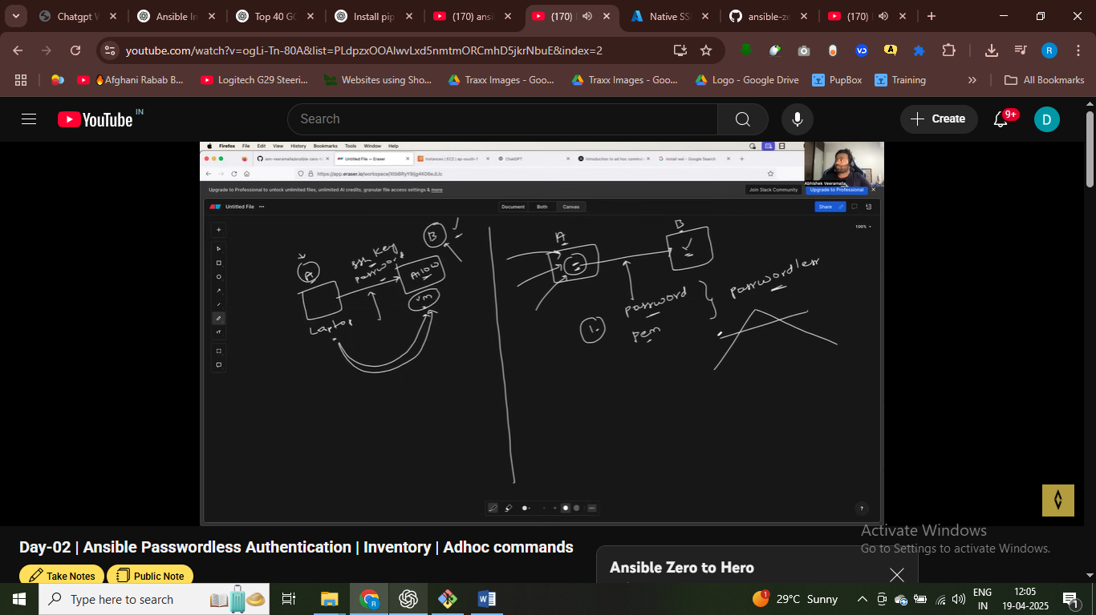

We will create 2 instnace machine – my laptop is control node and we create two manage node

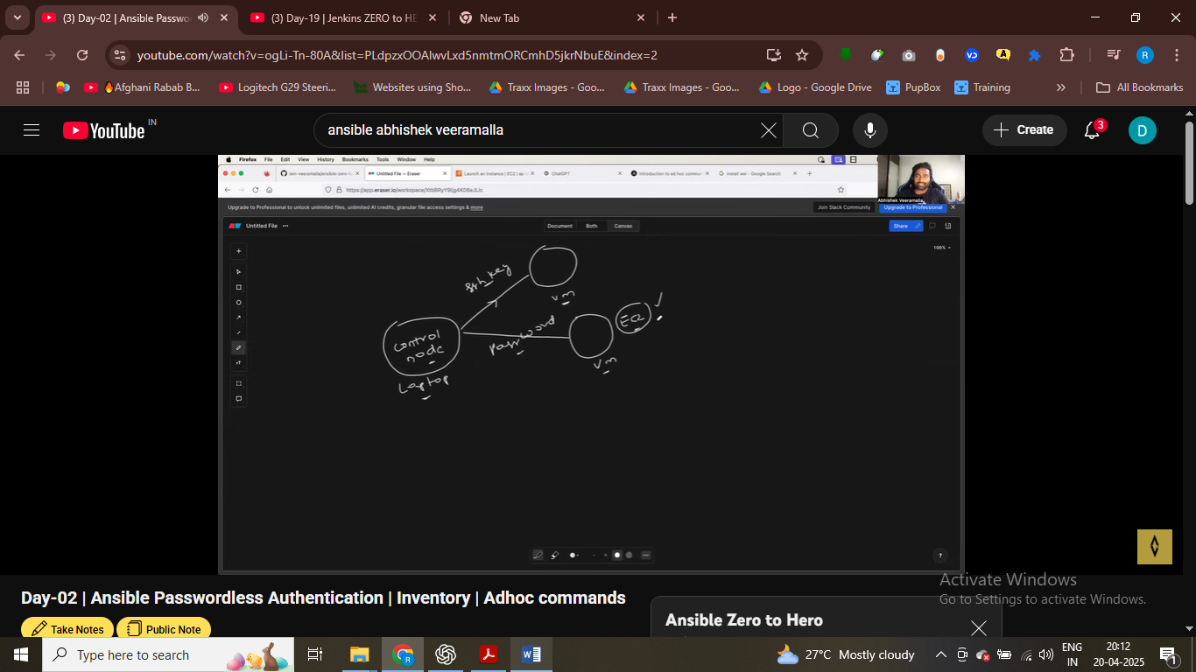

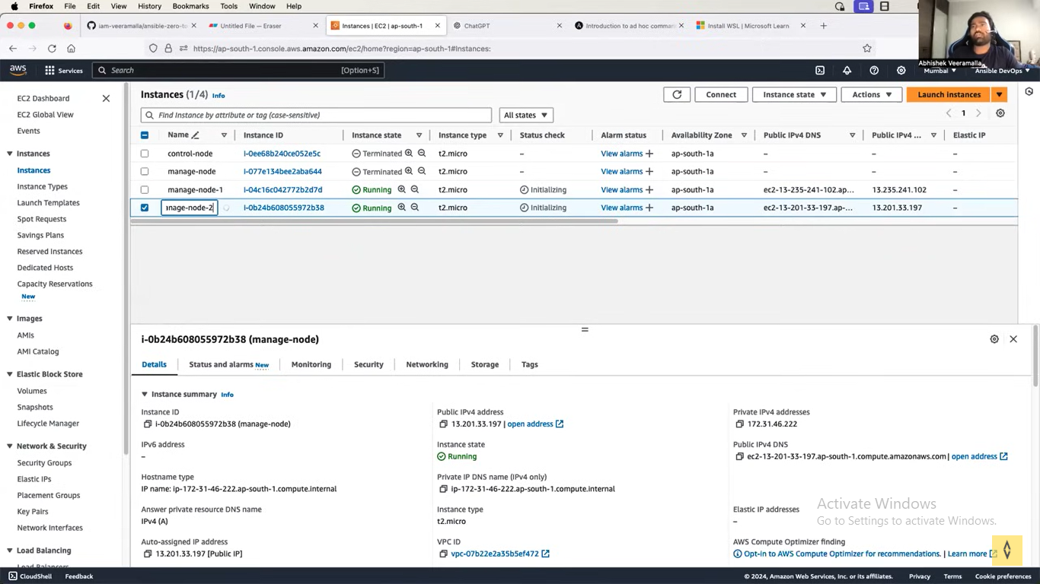

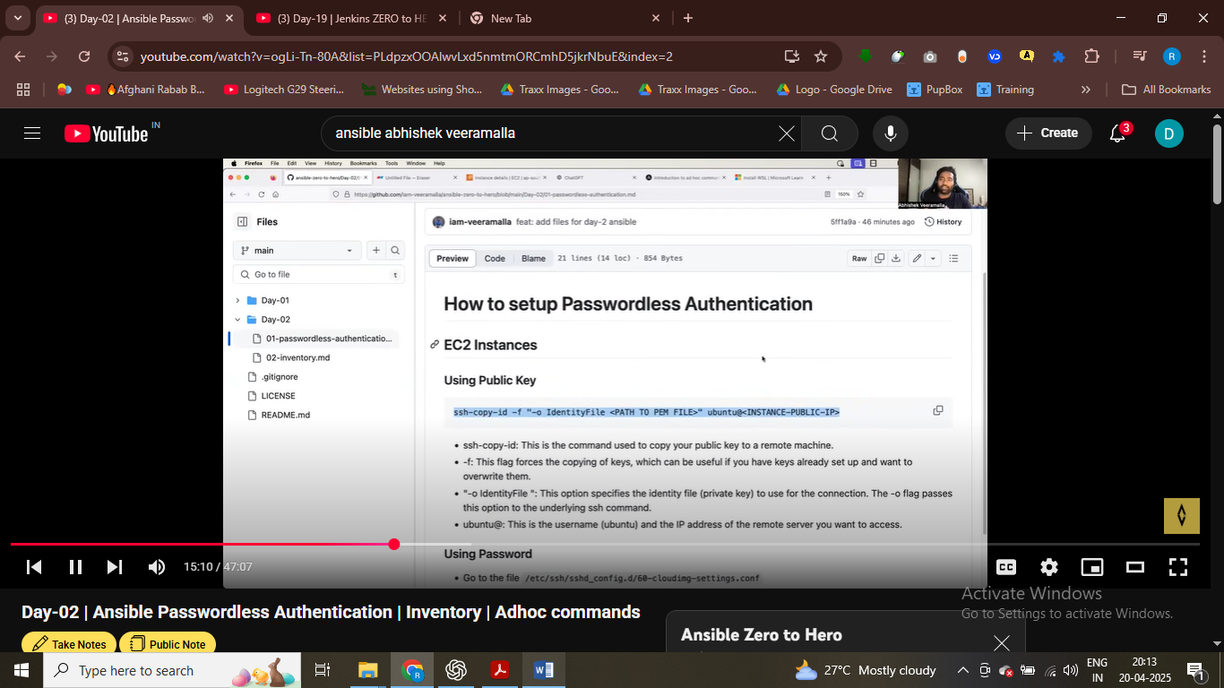

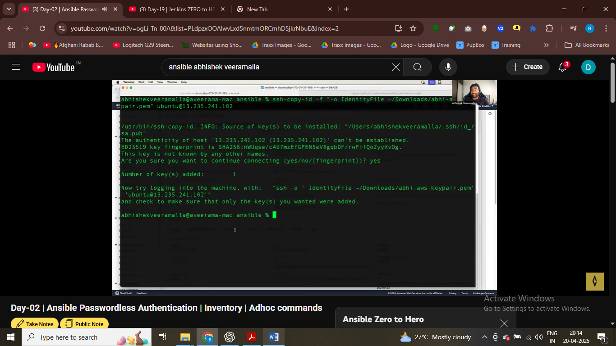

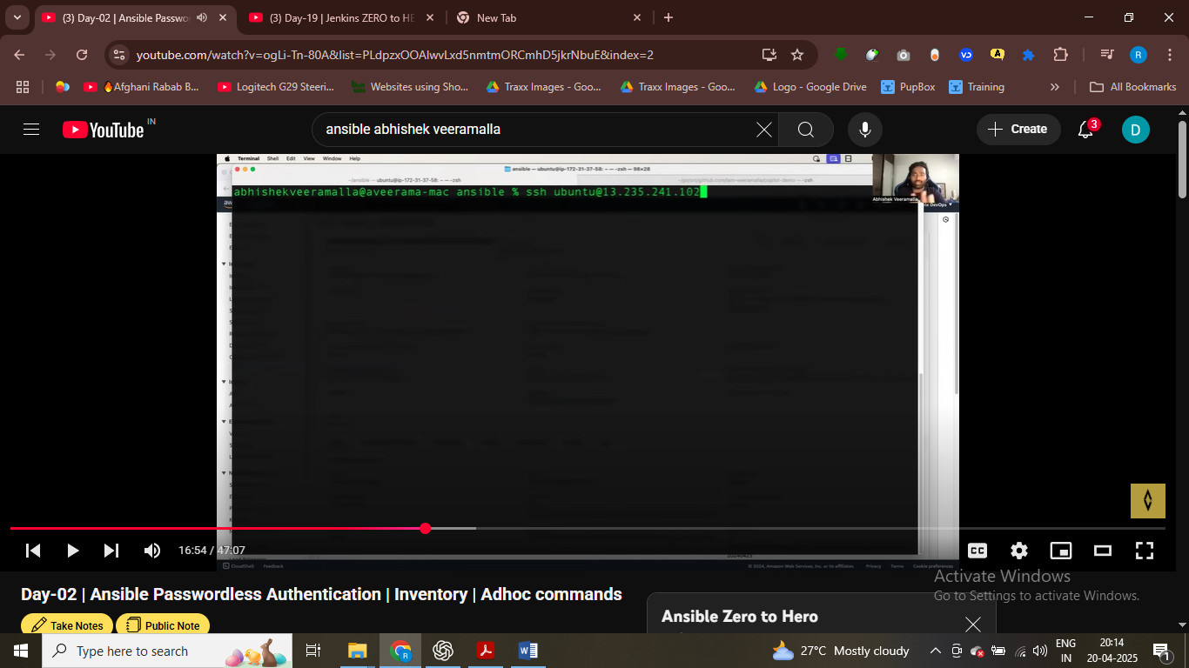

Now I can directly ssh itno machine with public after setting up password less authentication

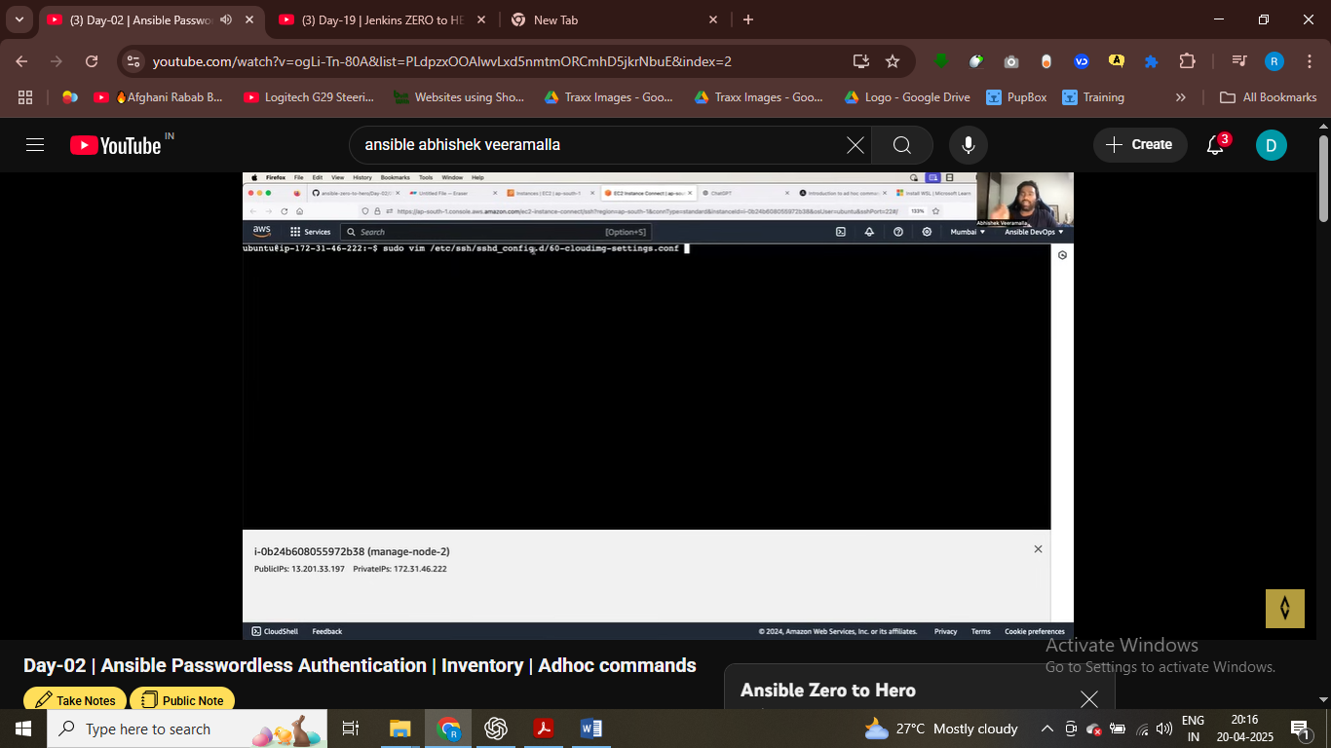

Login into second intnacec

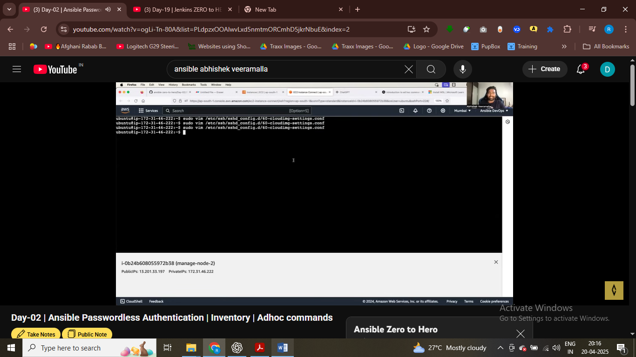

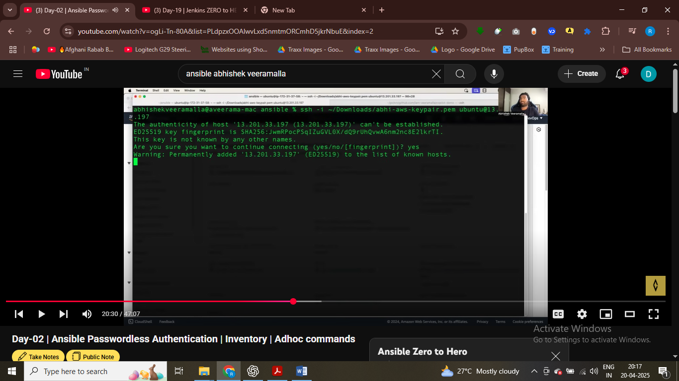

# g

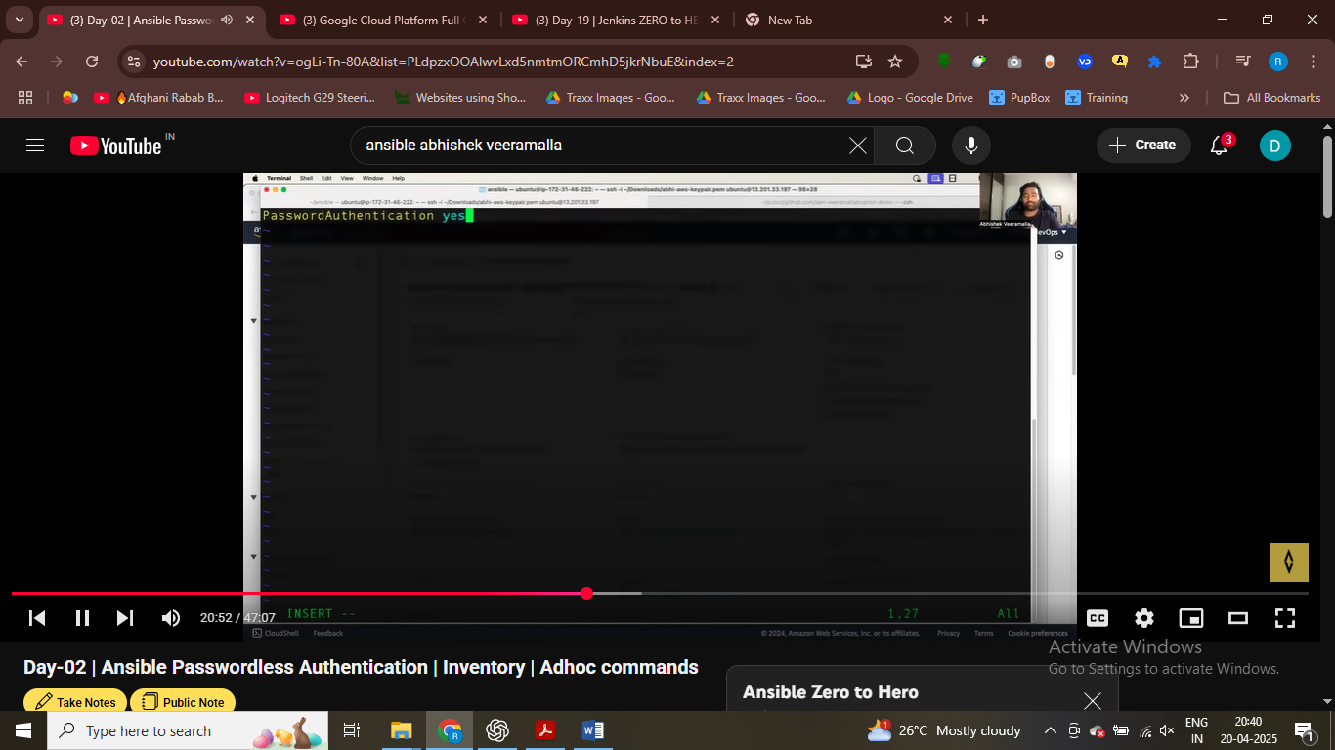

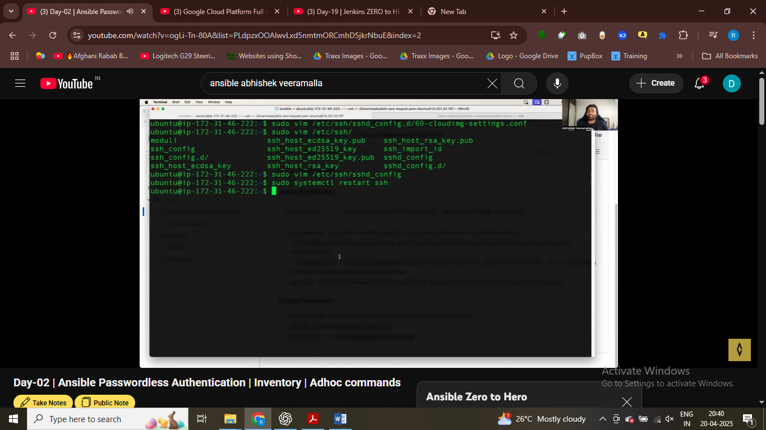

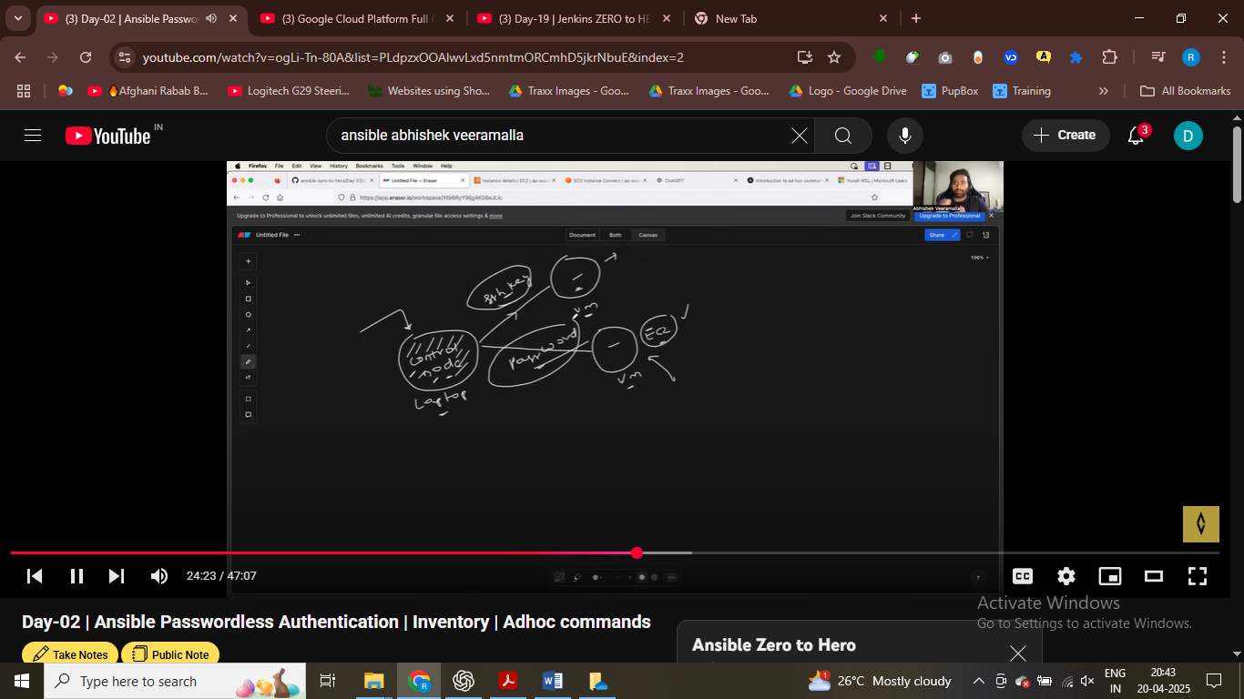

# password less authentication setup successfully

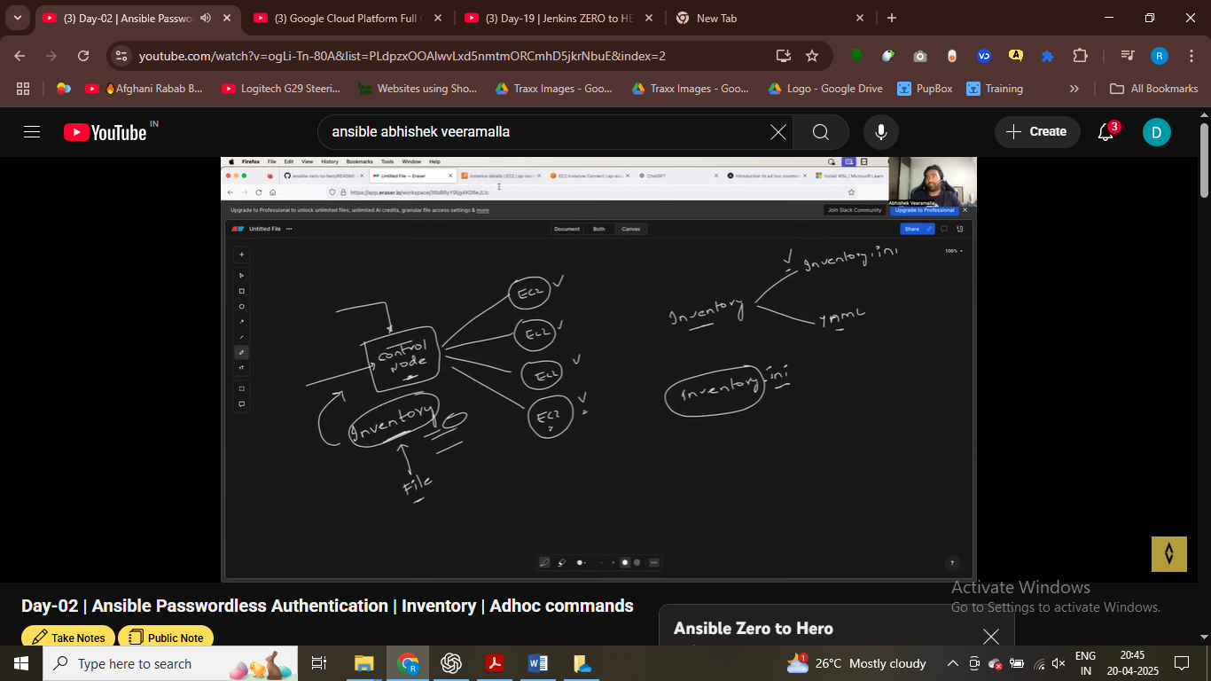

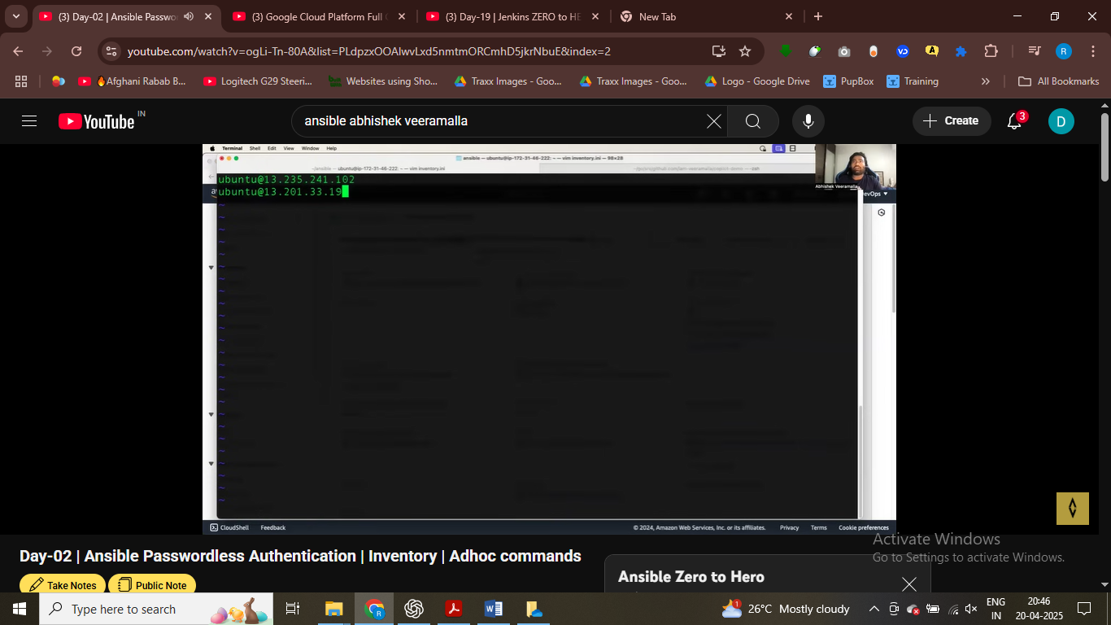

Writing ansible inteventory.ini file

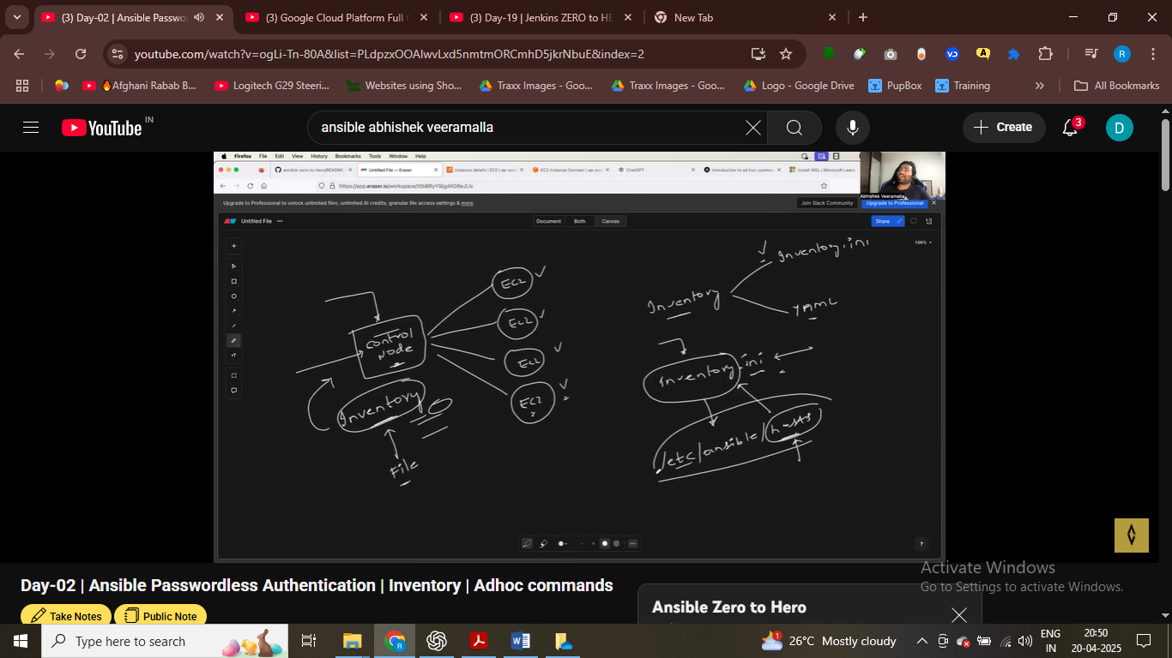

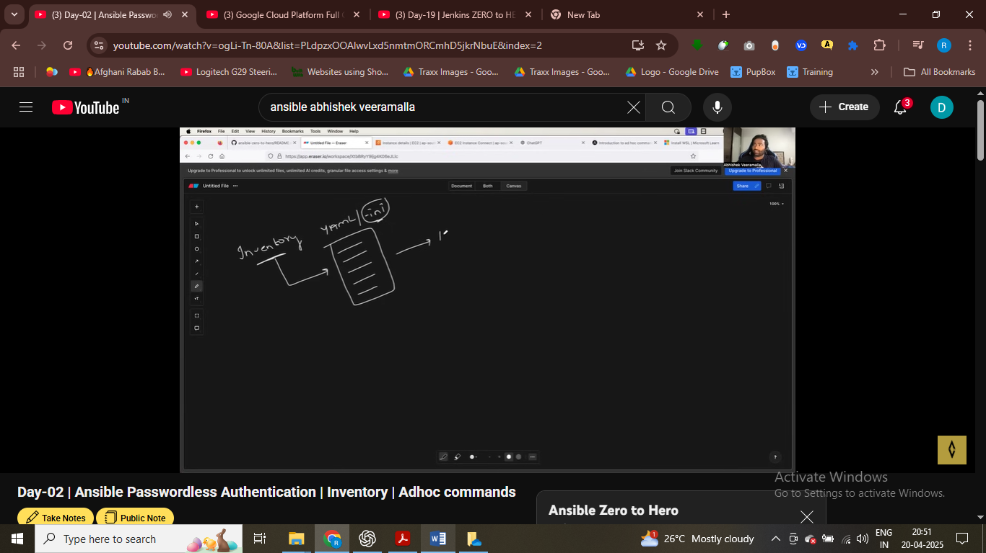

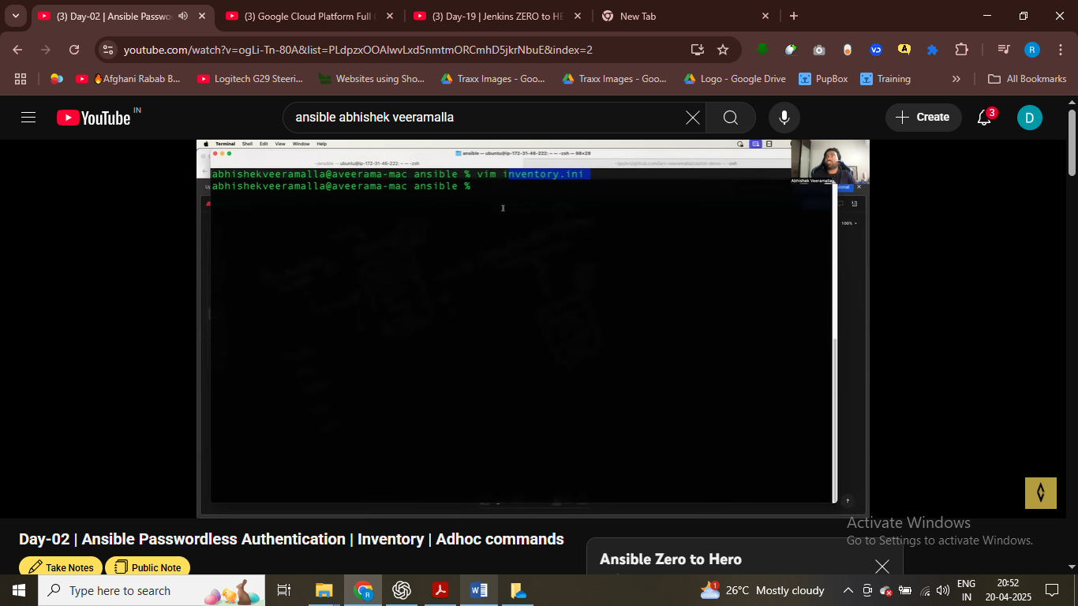

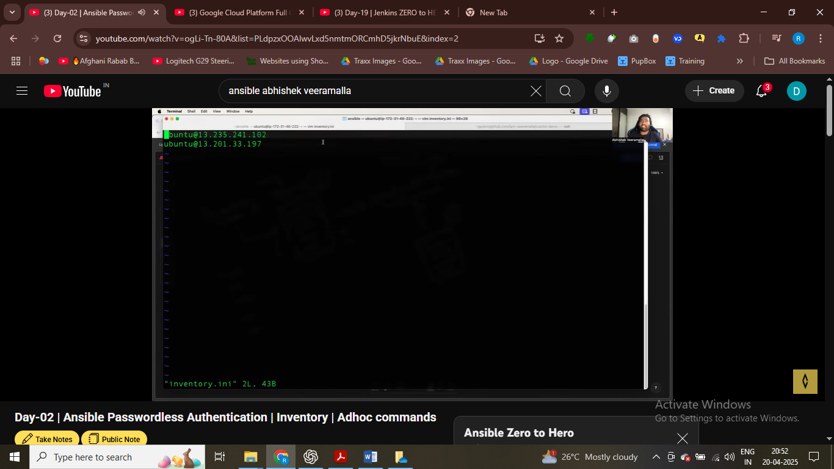

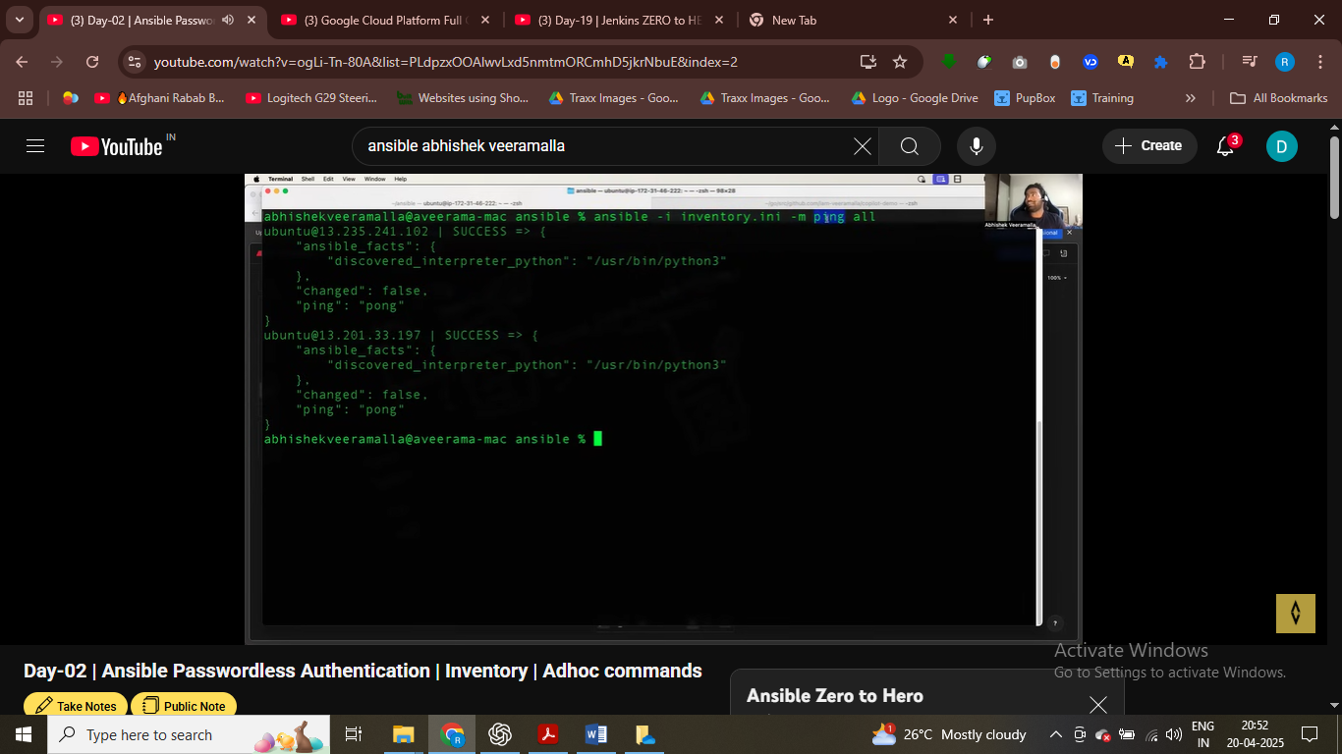

-I refer to currecnt location and –m moduel ping usd to ping all the server that is present in inventory.ini

Command ping on both server execute

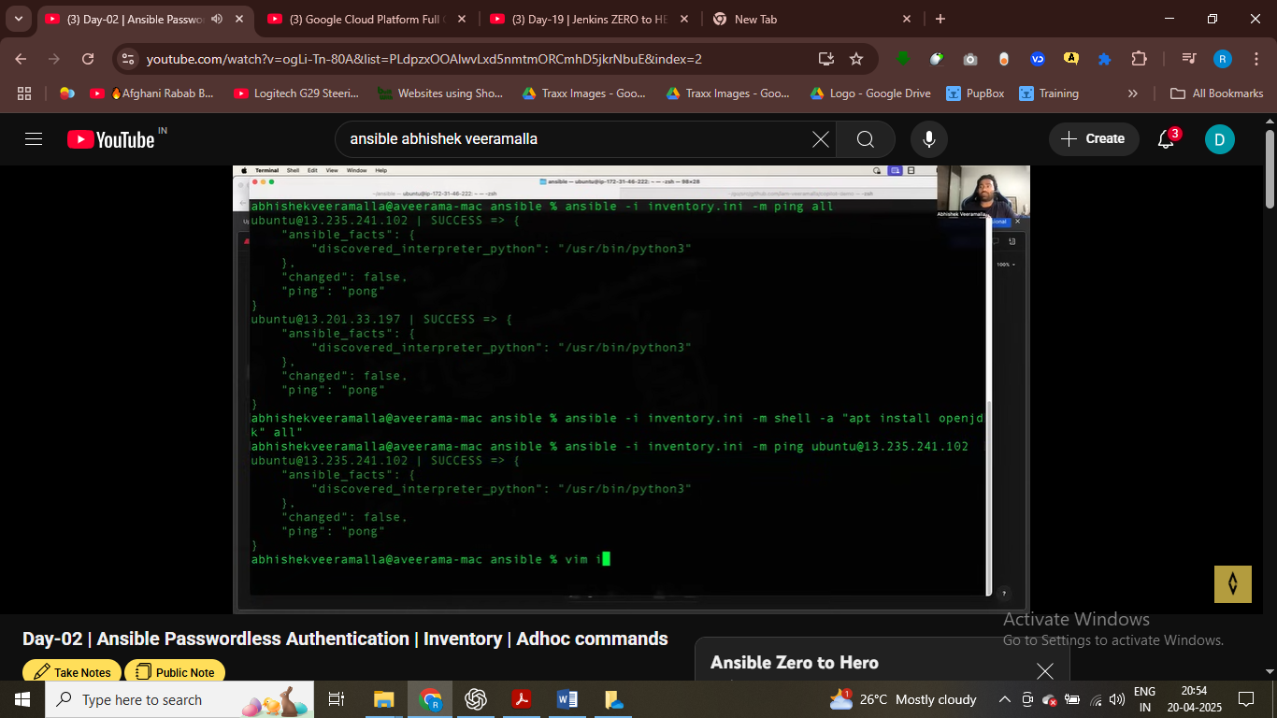

# -a refr to all server , passing arguments

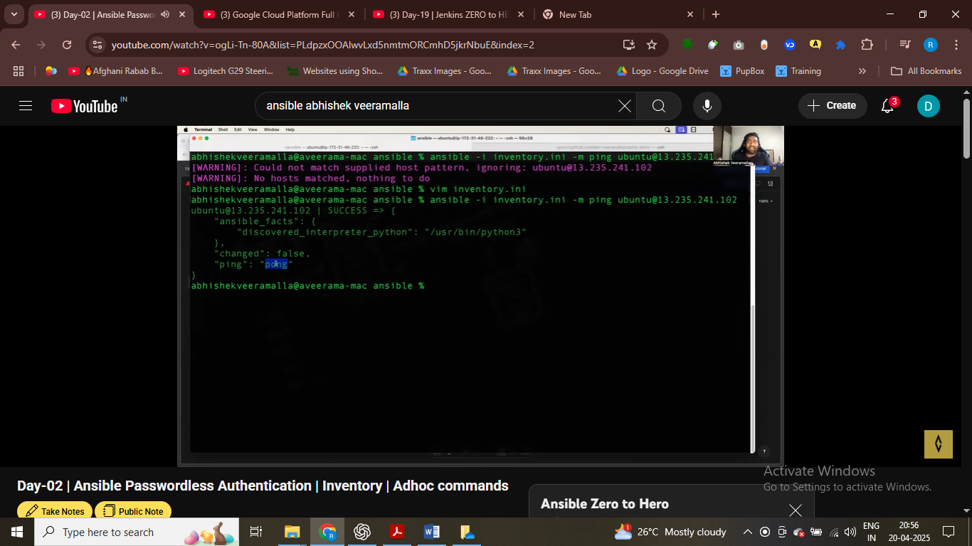

Put all the manage node in inventory file

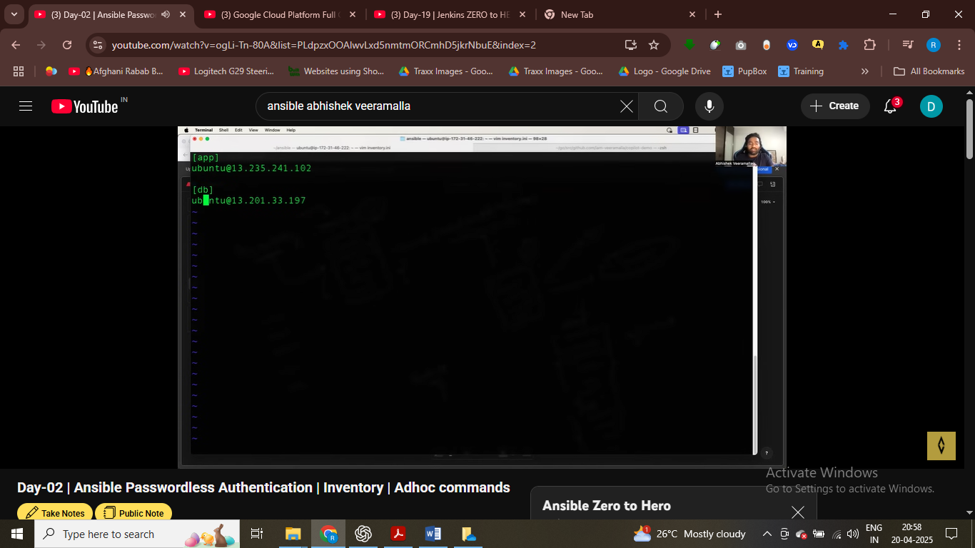

# ping all the db server

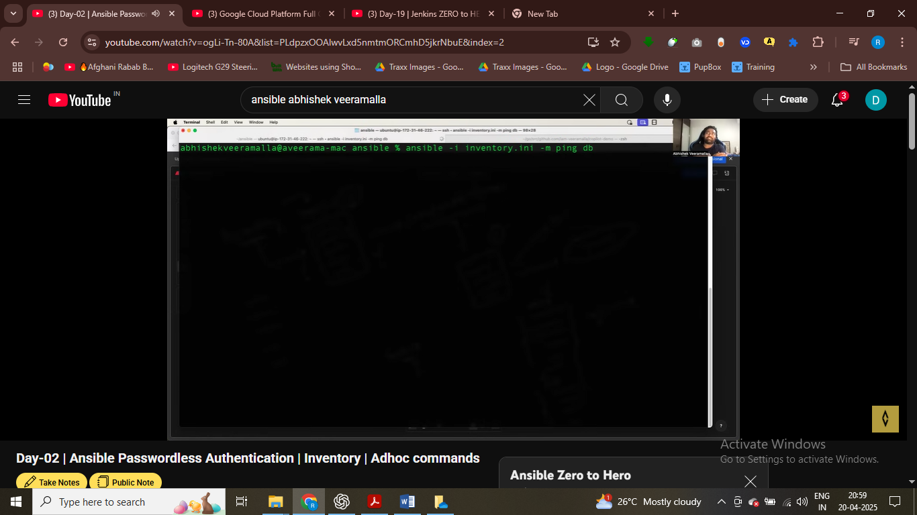

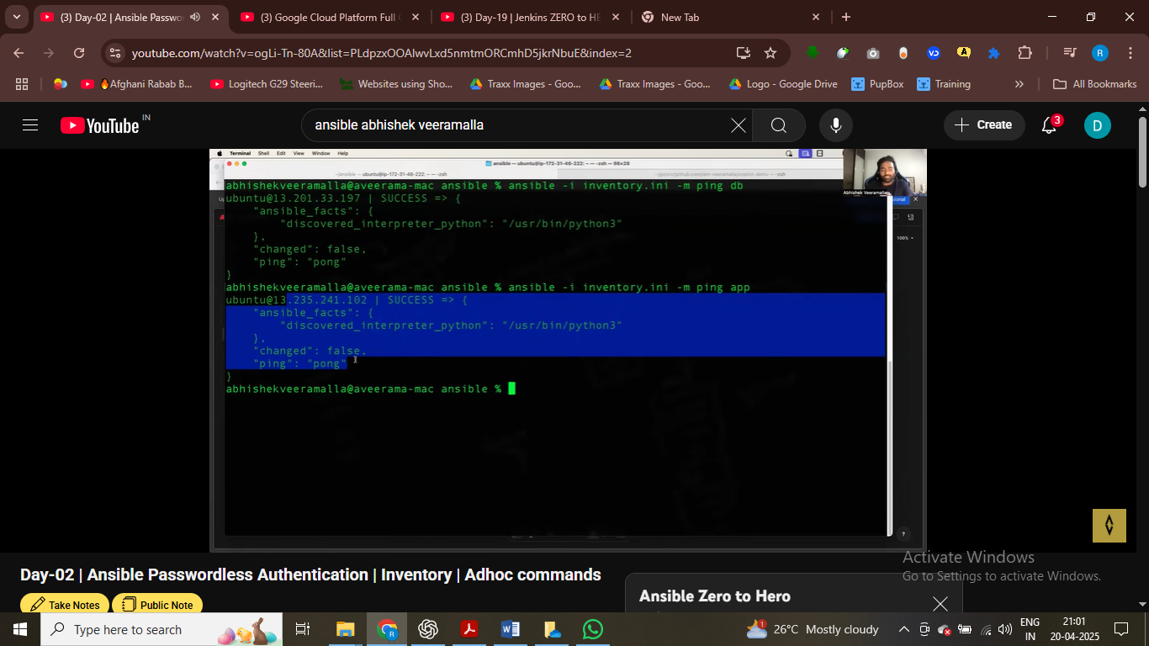

# ping all the app server

ping all the db server

Adhoc cmd

Like aws cli cmd you are giving itstuction

For simple task – restarting server , install something use adhoc cmd

Playbook

* Task take 50 line or steps , complicated
* Use playbook

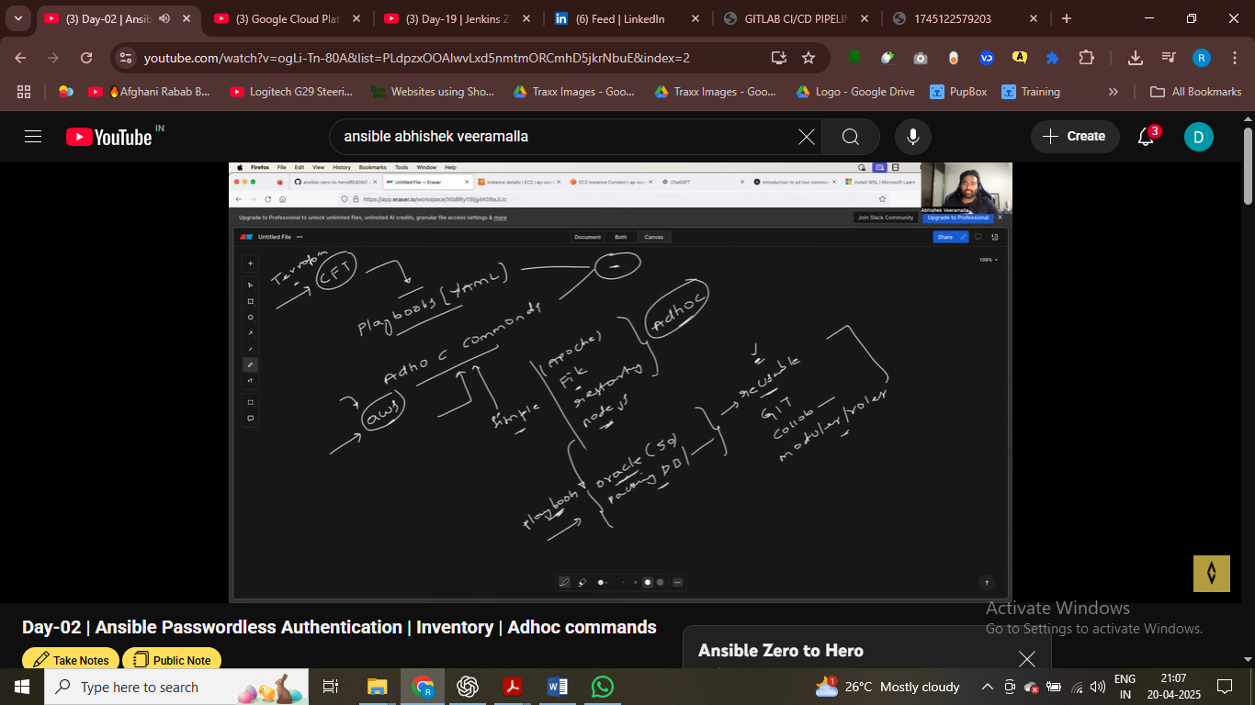

If your task just like testing server use ping modules

Playbook resusable , can share on git , collbrate other people

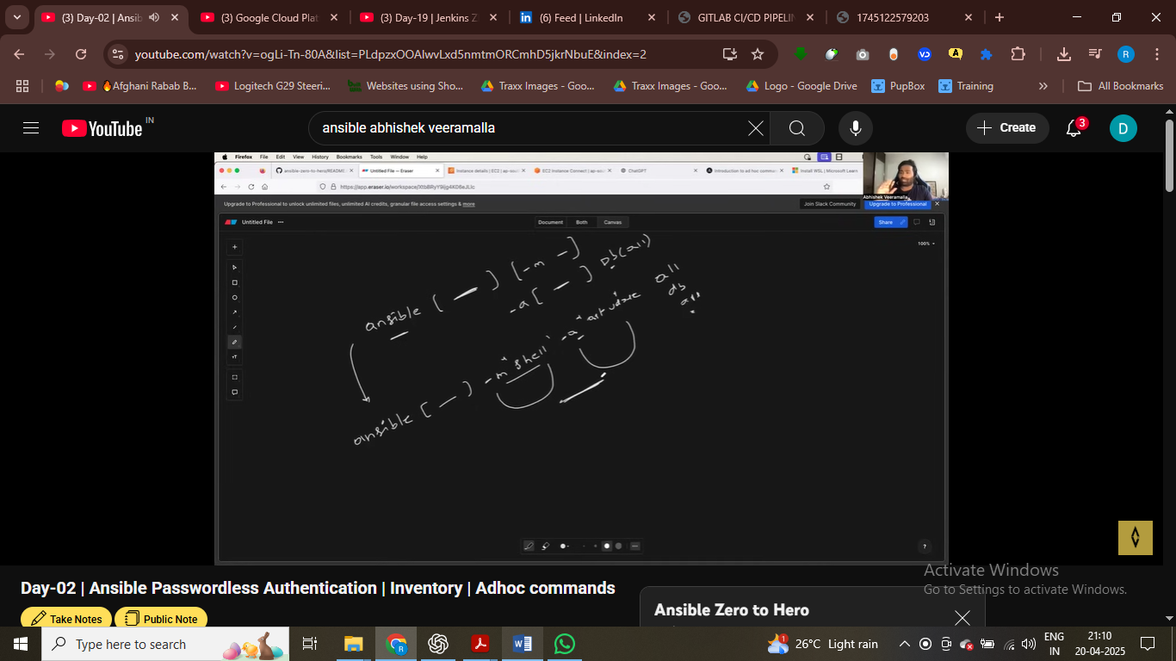

Adhoc cmd synatax using module ping here and –a for all

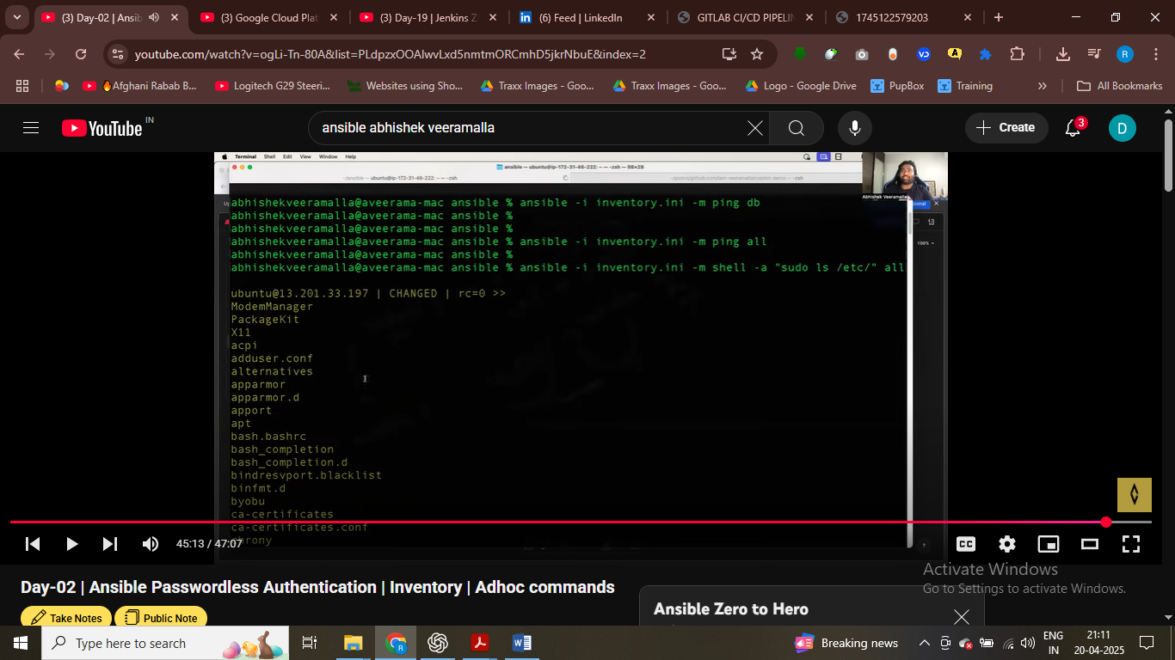

Ansible now execute the task on my both of machine

Adhoc manage file , update some files , delete some files – they are used for this type of task – adhoc cmd

* Crate apache crate gninx – basic cmd used for adhoc cmd

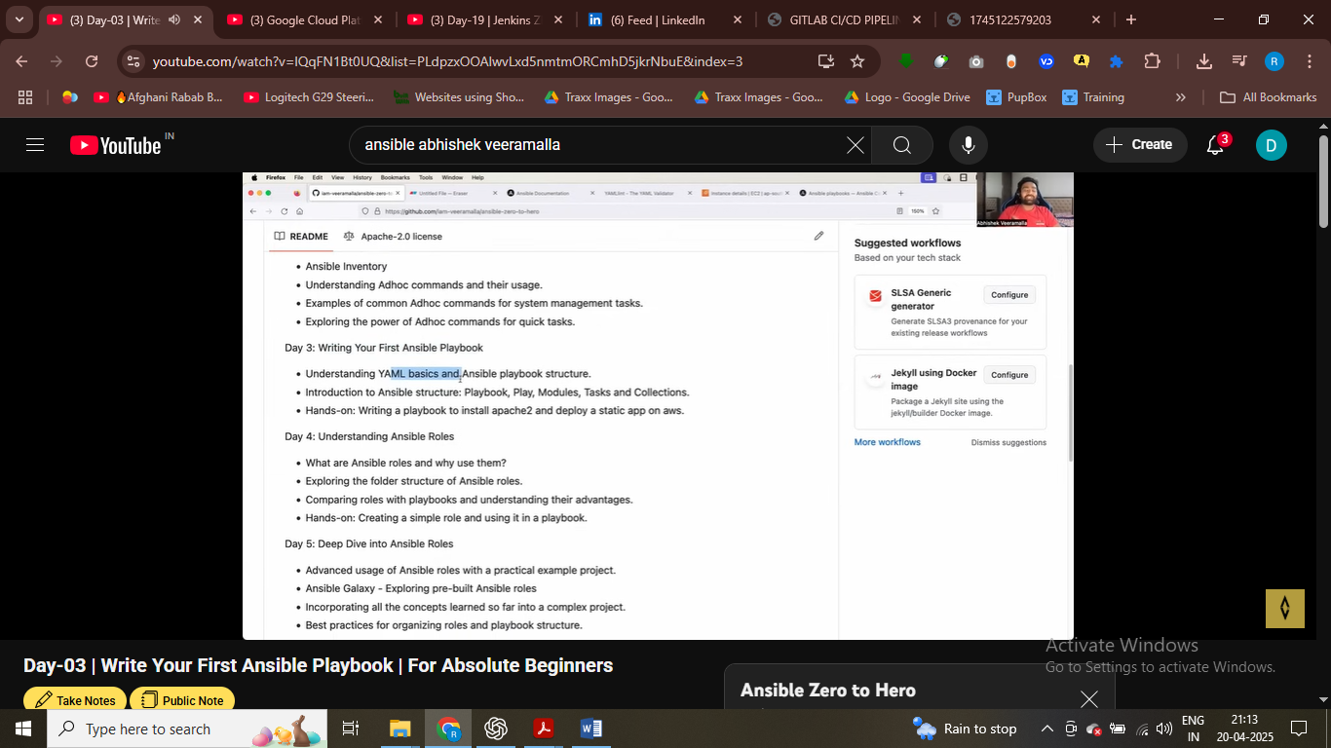

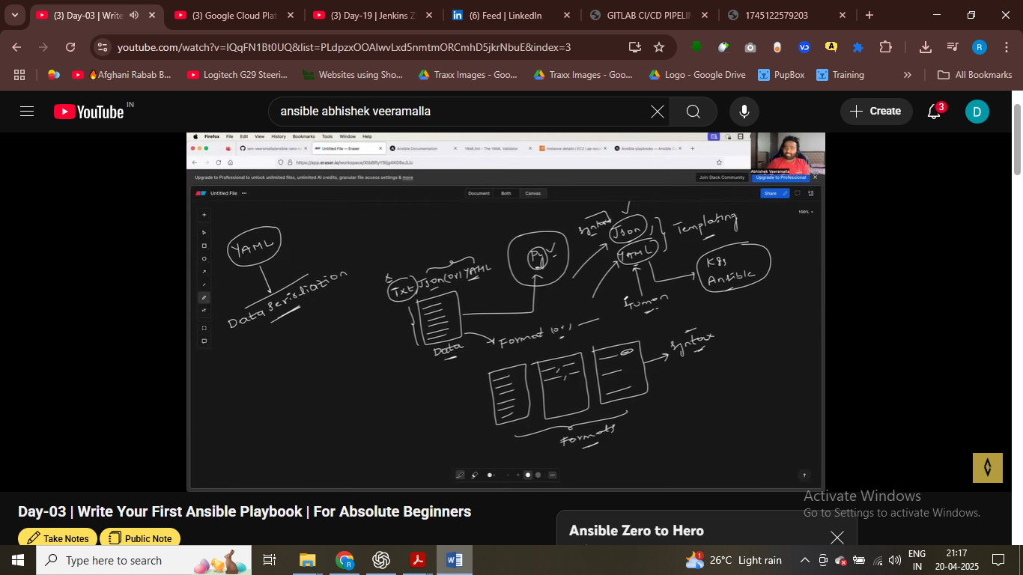

* Yaml human readabale asd compare to json

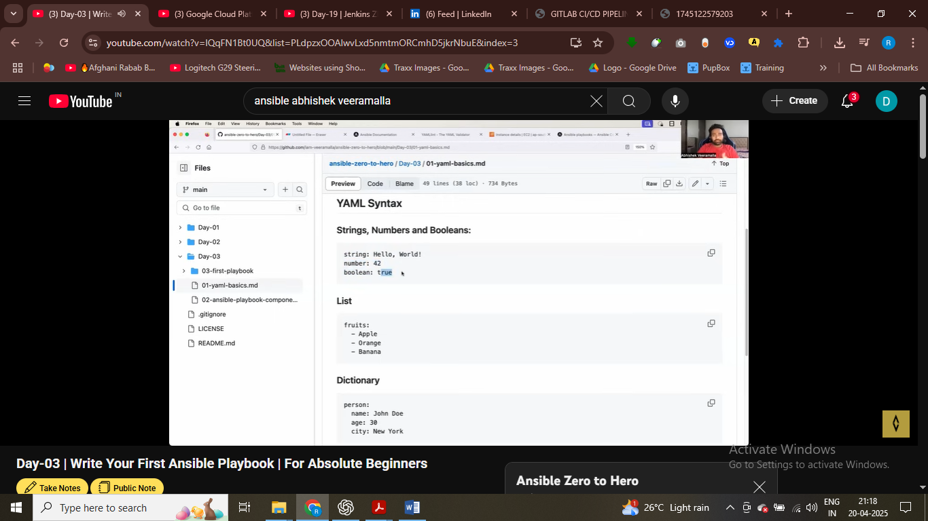

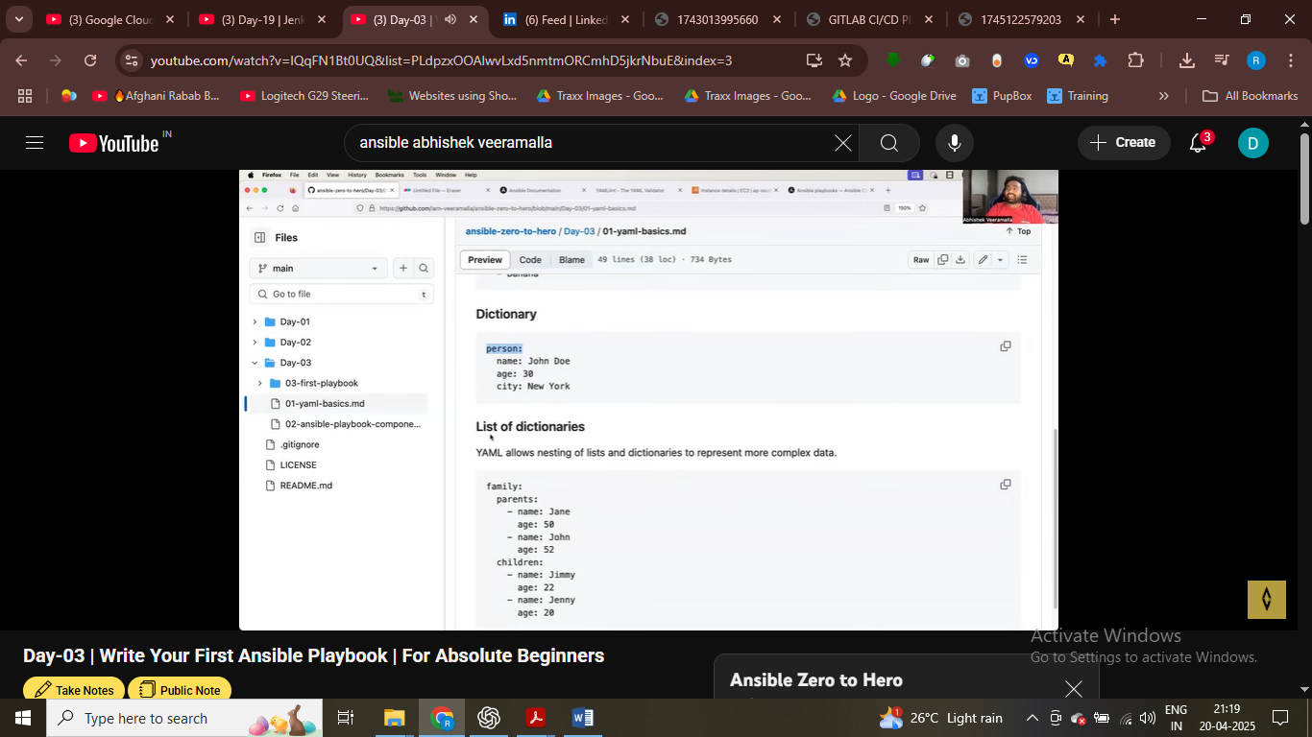

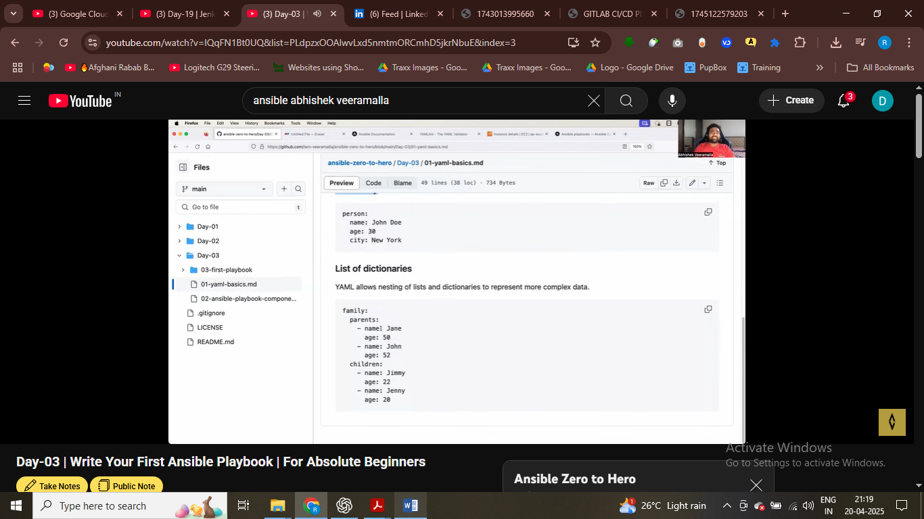

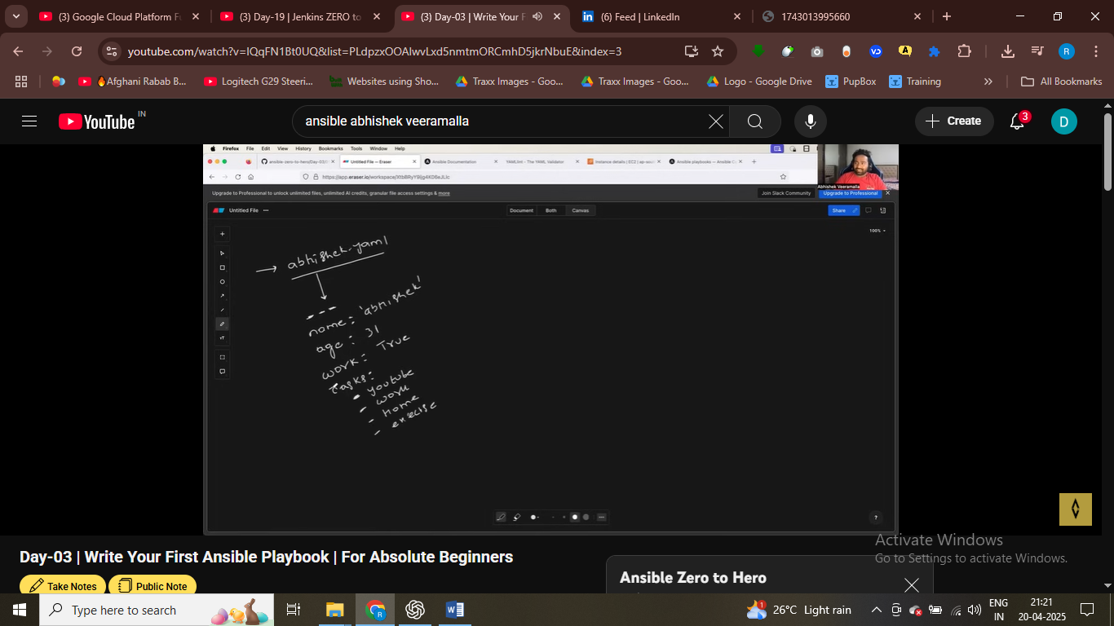

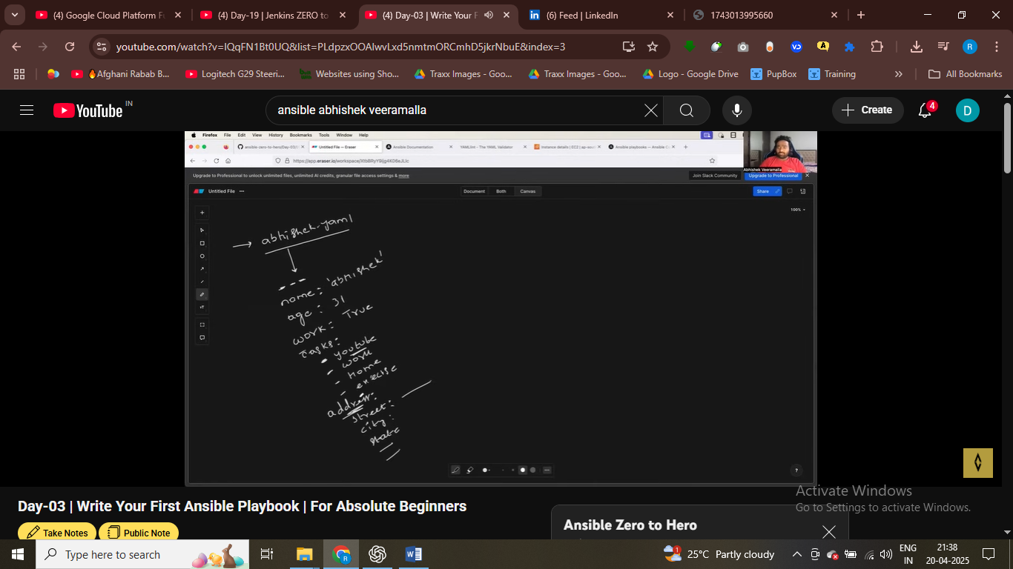

Yaml files

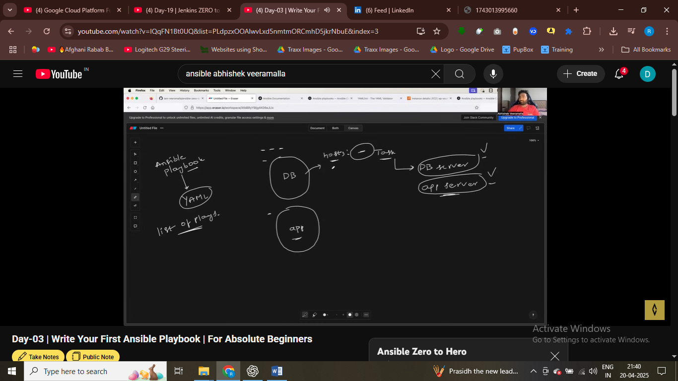

Task like install nginx and another task like start nginx

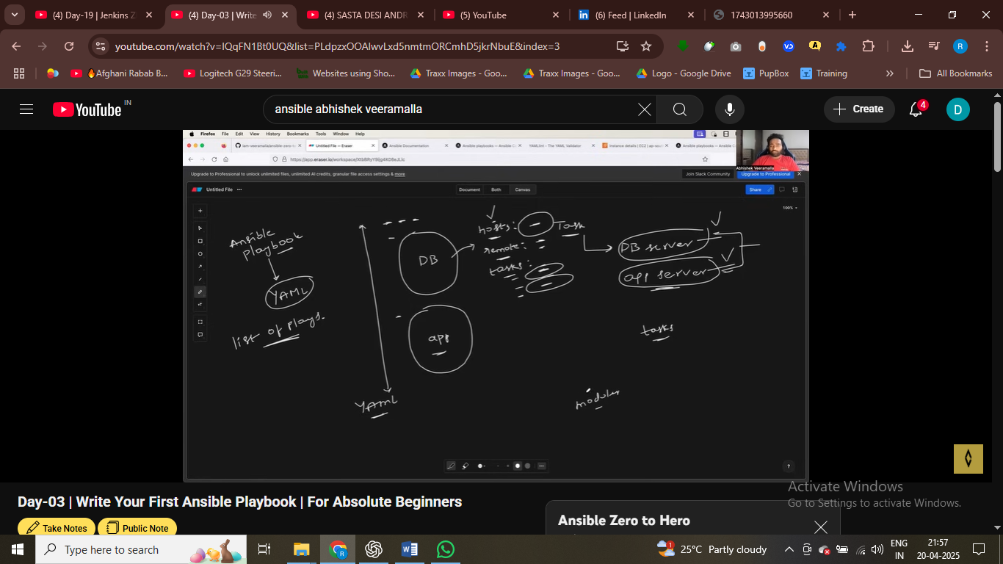

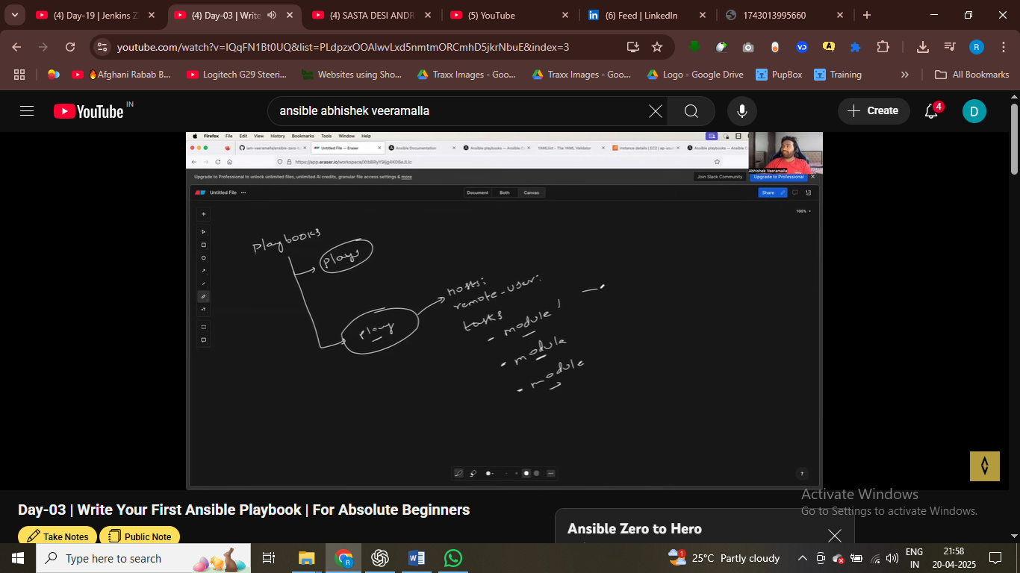in task we need to use modules

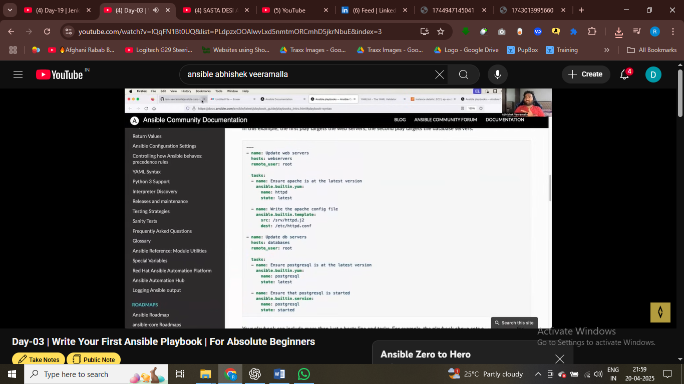this is moduel built in module we are using

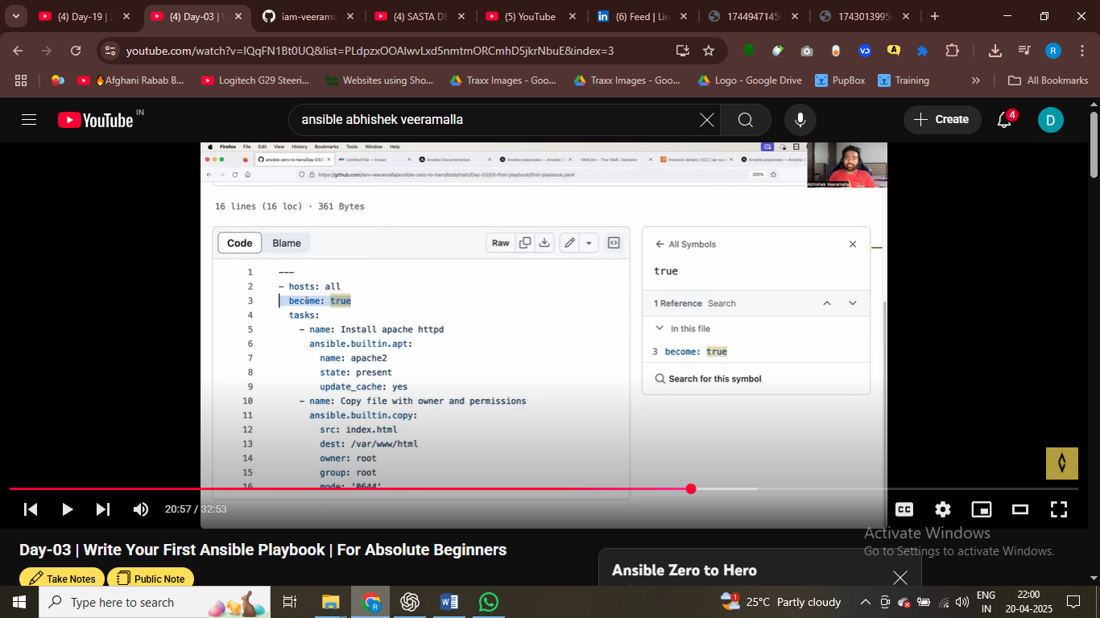become true run with root user

If I don’t provid this then it run with current user – which is Ubuntu user we have

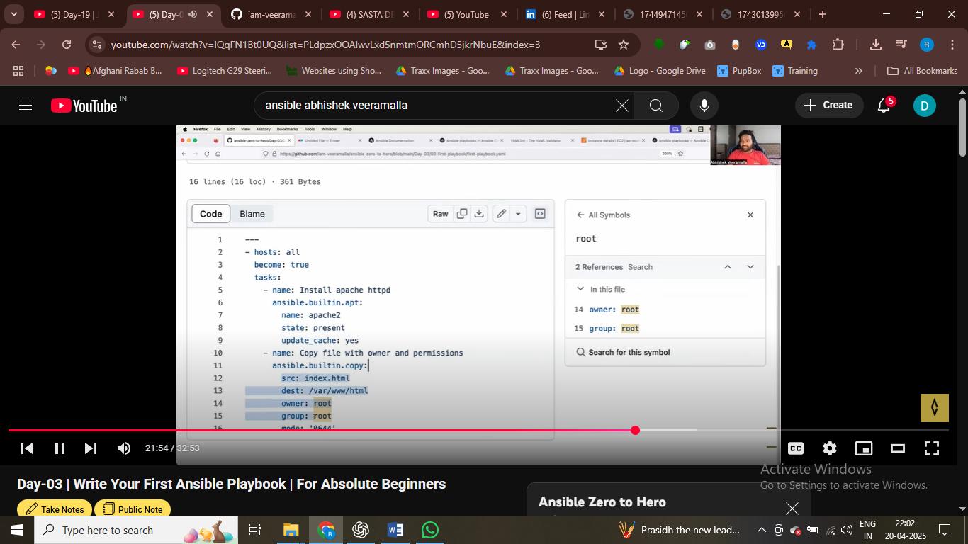ansible.built.in module here

Here we define two task one task isntlal apache and the other teask copy html file

https://github.com/iam-veeramalla/ansible-zero-to-hero

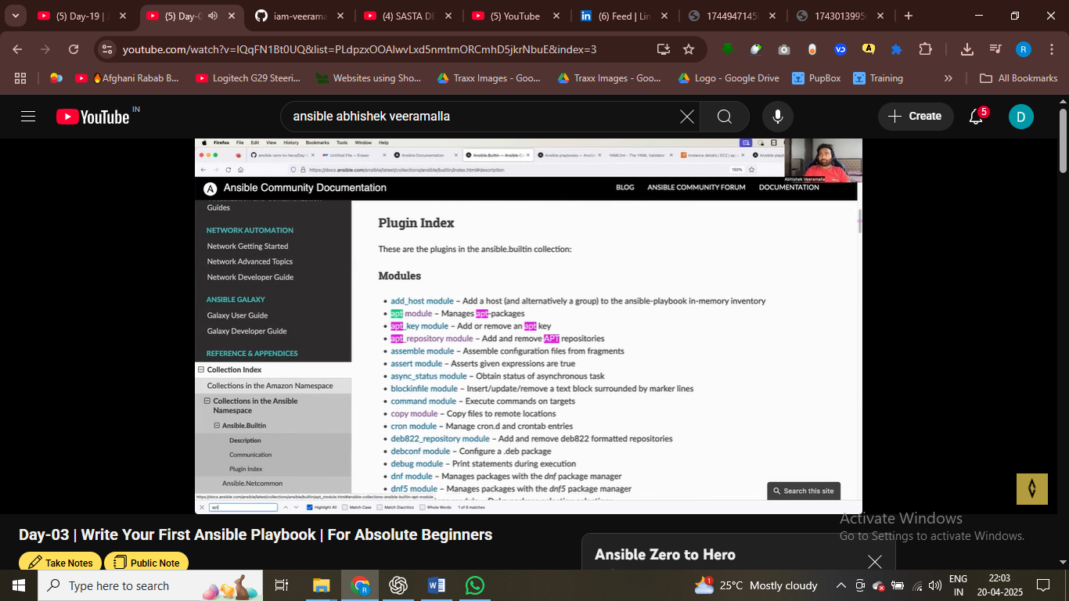

<https://github.com/iam-veeramalla/ansible-zero-to-hero/blob/main/Day-03/03-first-playbook/first-playbook.yaml>

built in module and custom moduele we have two module we have

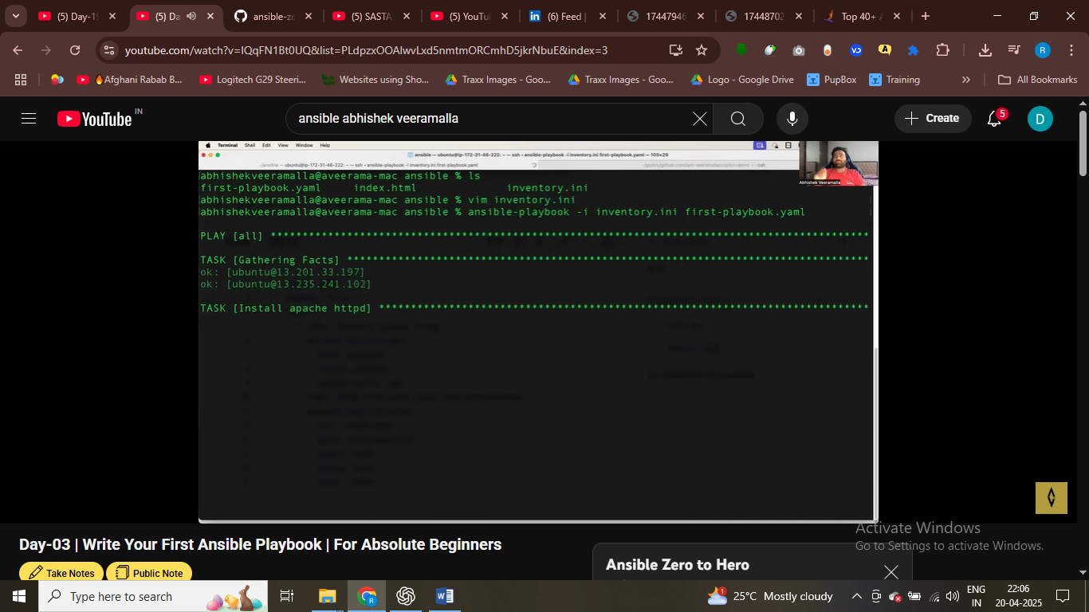

# hosts : all refer to run these against all hosts

First task is gather facts

i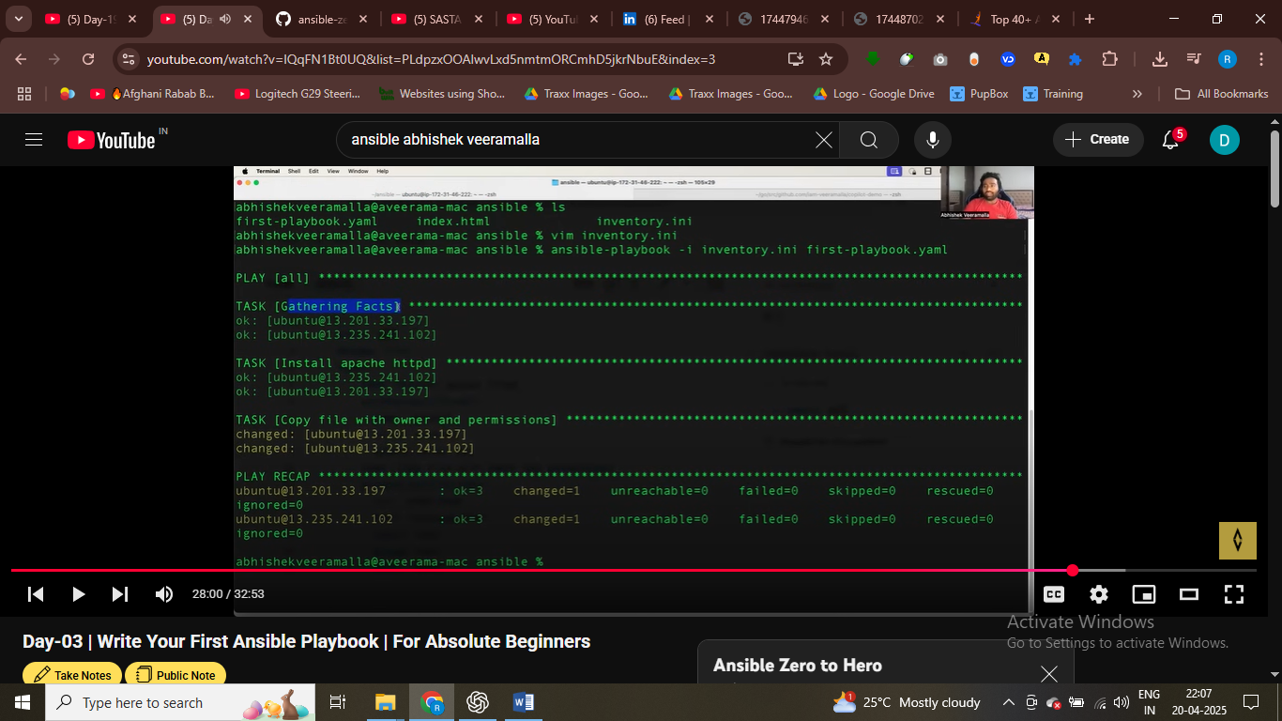

it means if we connect to ec2 instnace or not and gather all the information from it – gathering fact

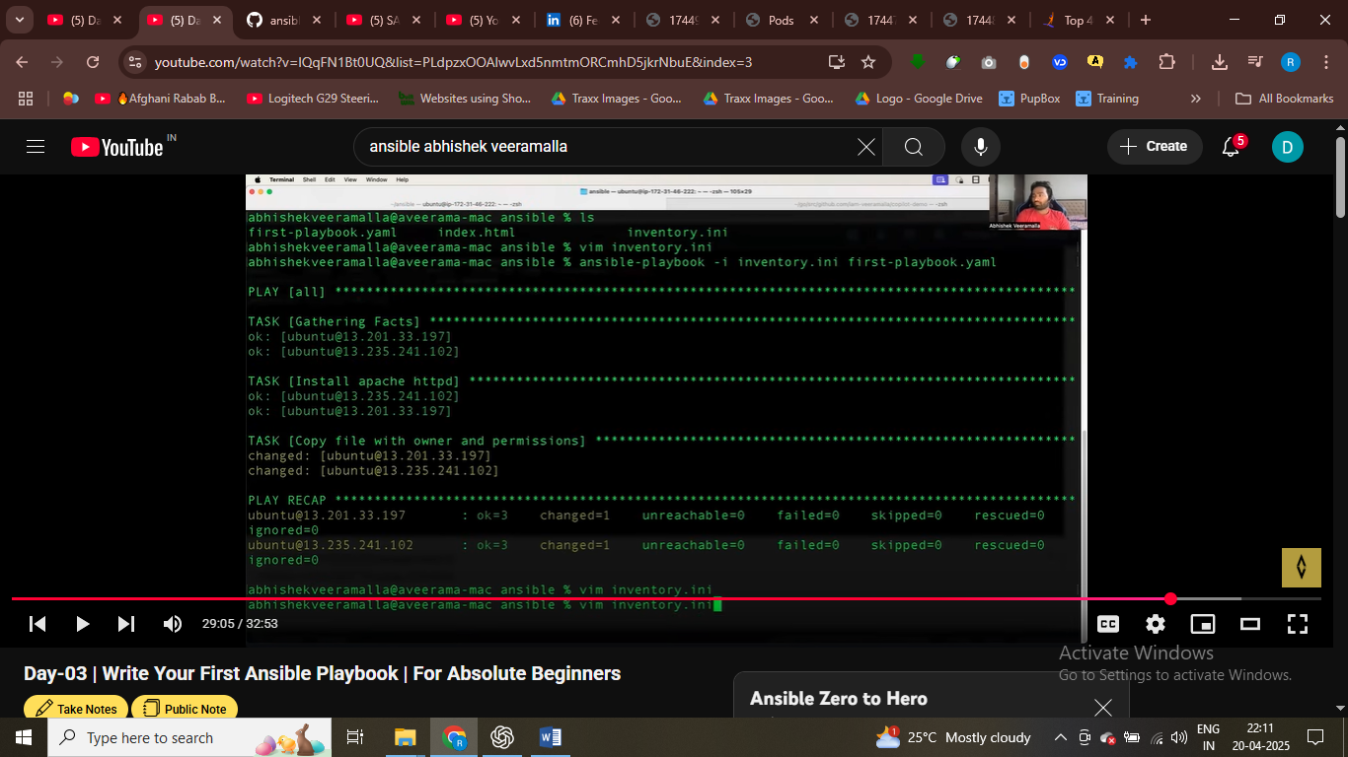first-playbook.yml

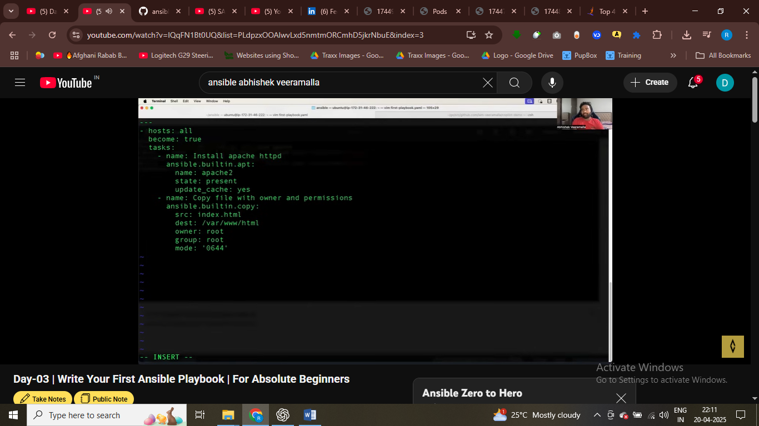steate present menas it will install or if state absent then it will not install apapche

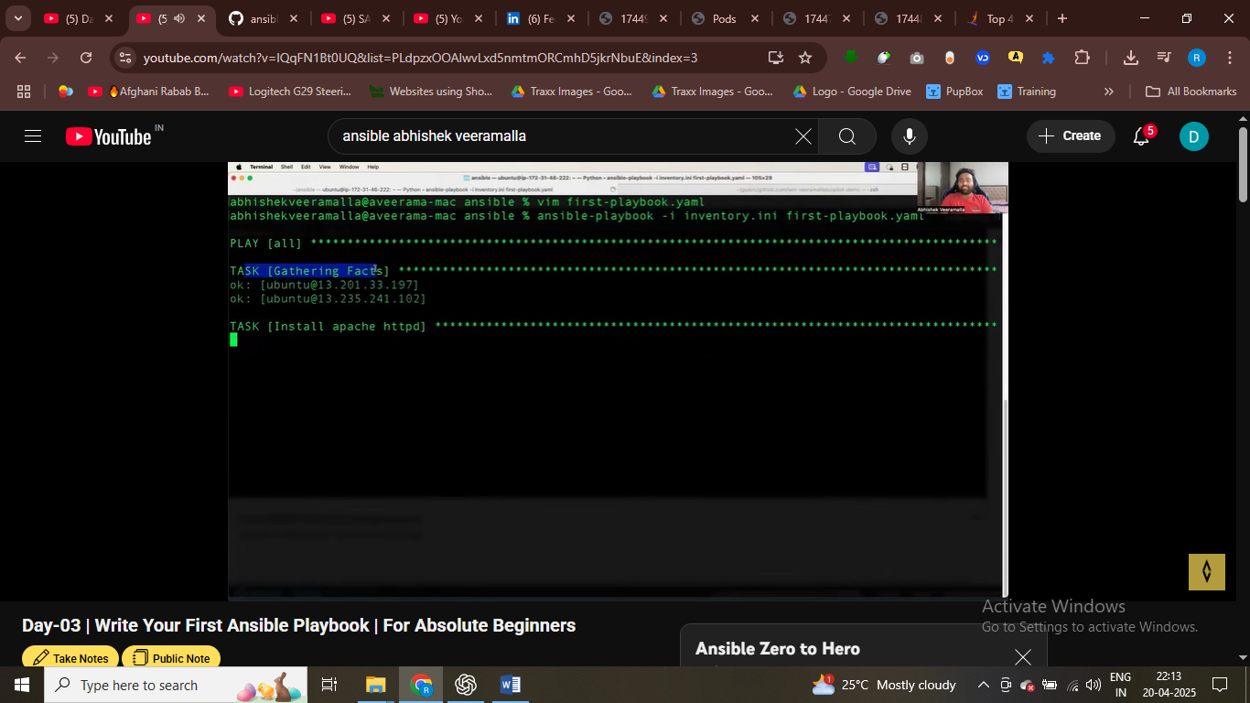

First task in playbook is gagthering fact – it means gather all the infor from ec2 insgtnace

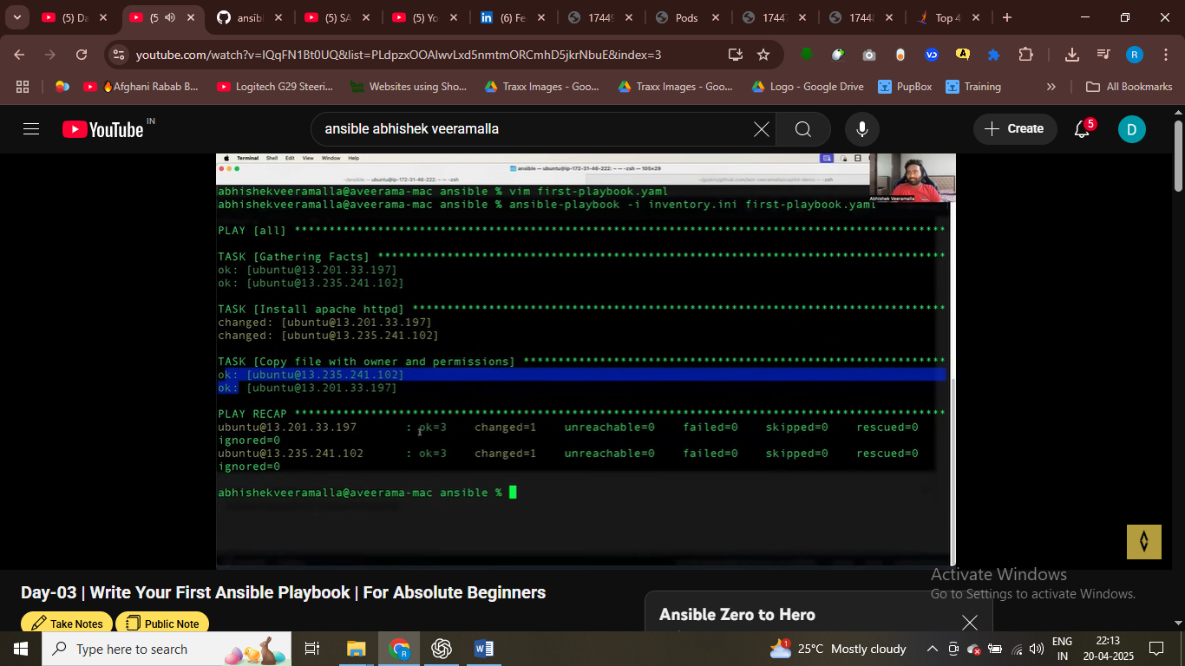

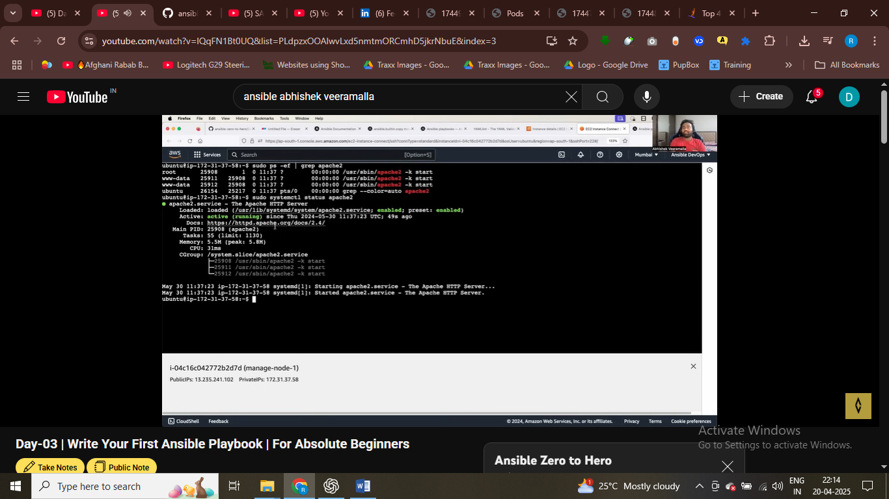check apache in ec2 isntnace running successfully

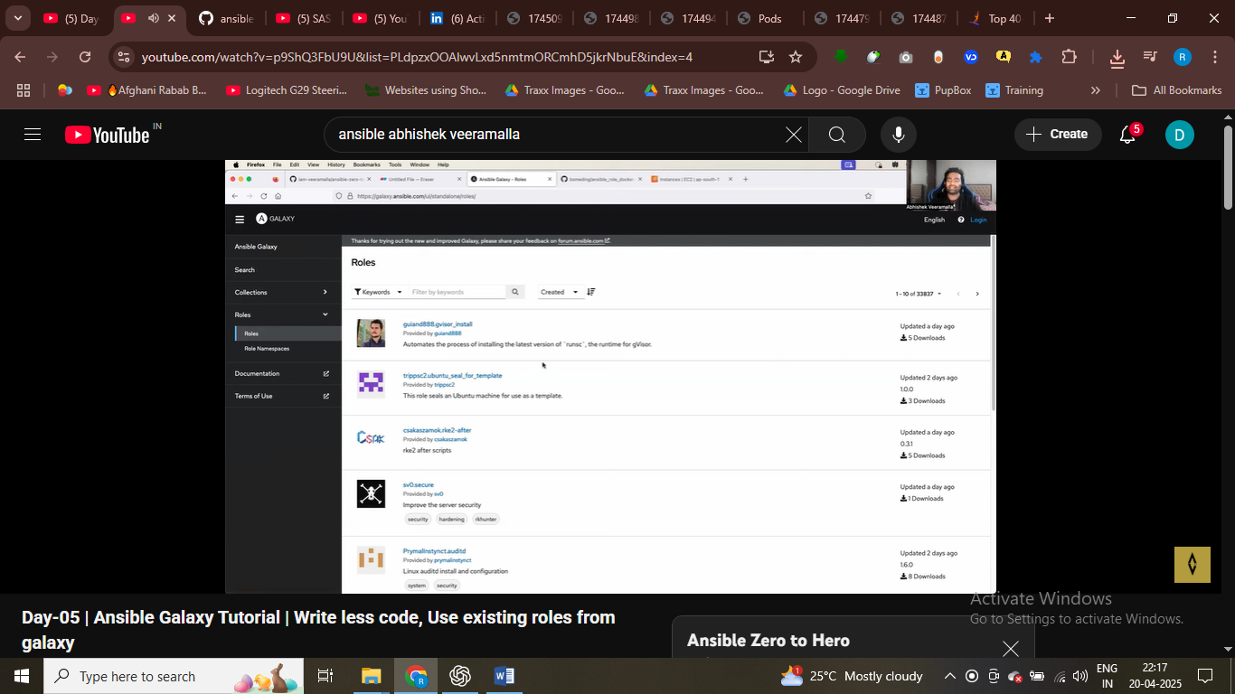

Ansoble galalxy has 1k of ansible roles have

Instead of wiritng common task you can use ansible roles

Ansible role bring modularity to code , readiblity

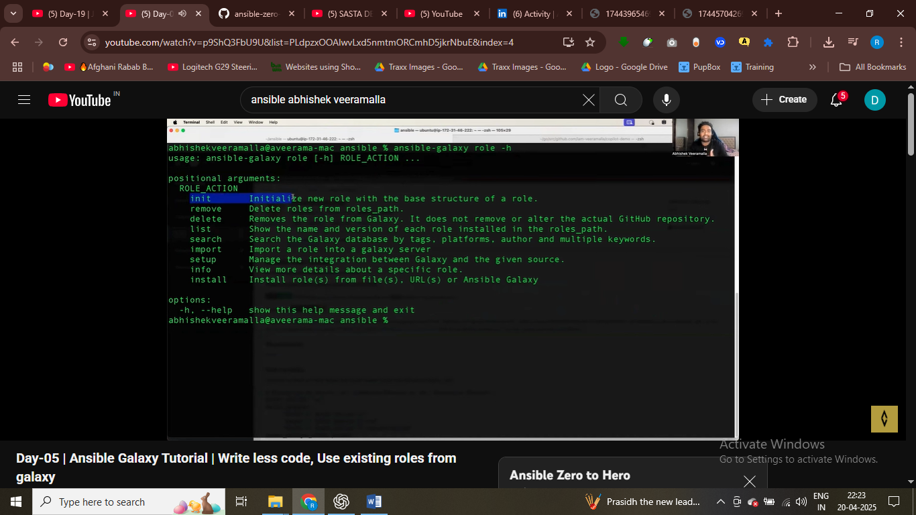

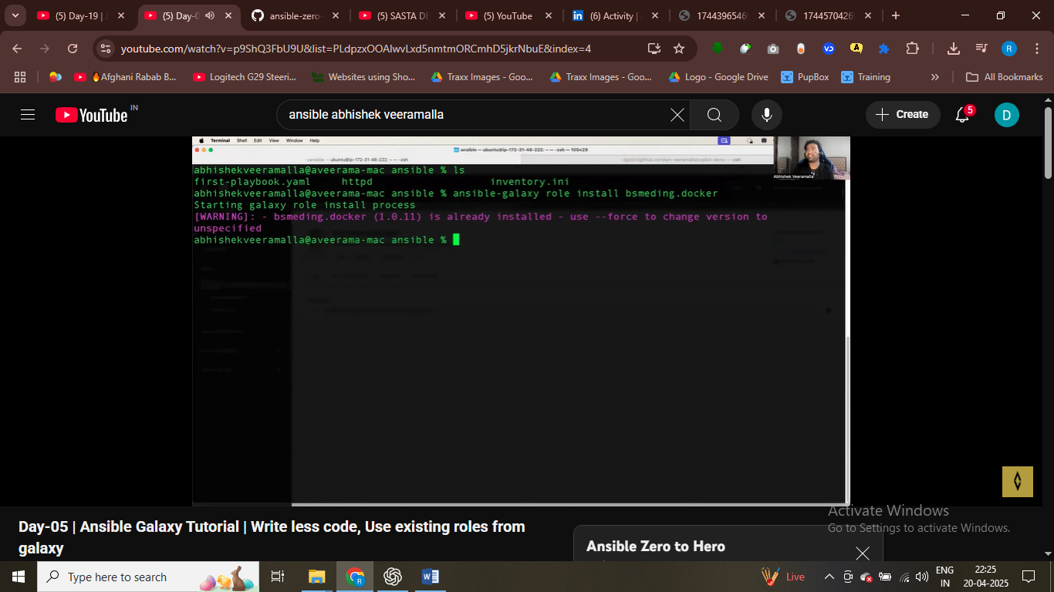

Login to ansible galaxy and install roles then

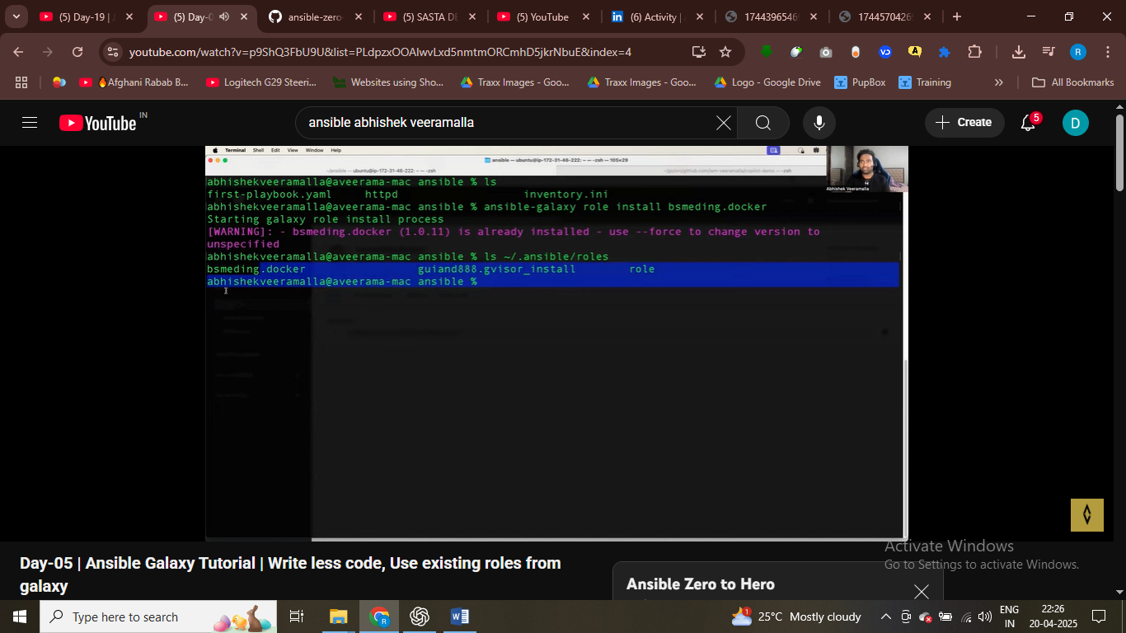

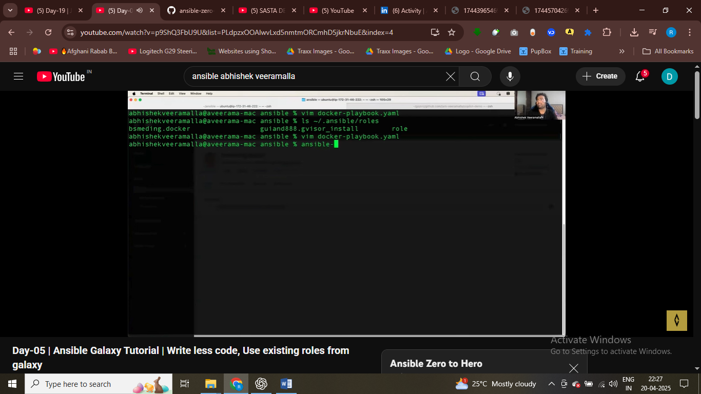

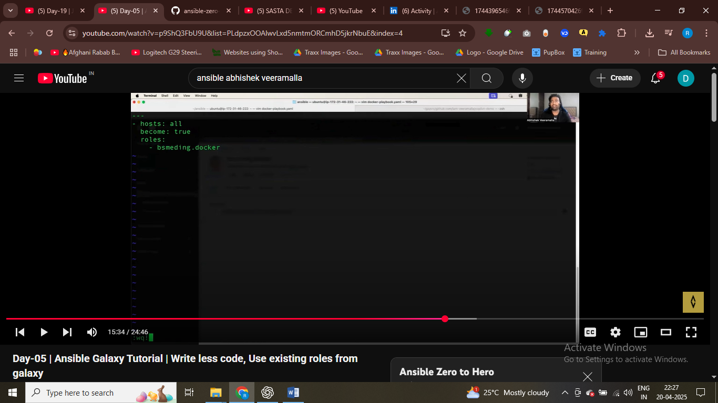

Using role docker that apply to all host

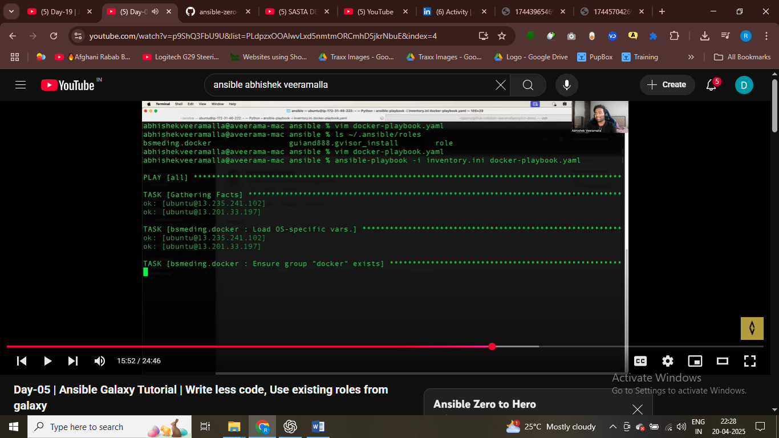

# I have installed docker om my ec2 using roles

Writing roles take carelot of tieme

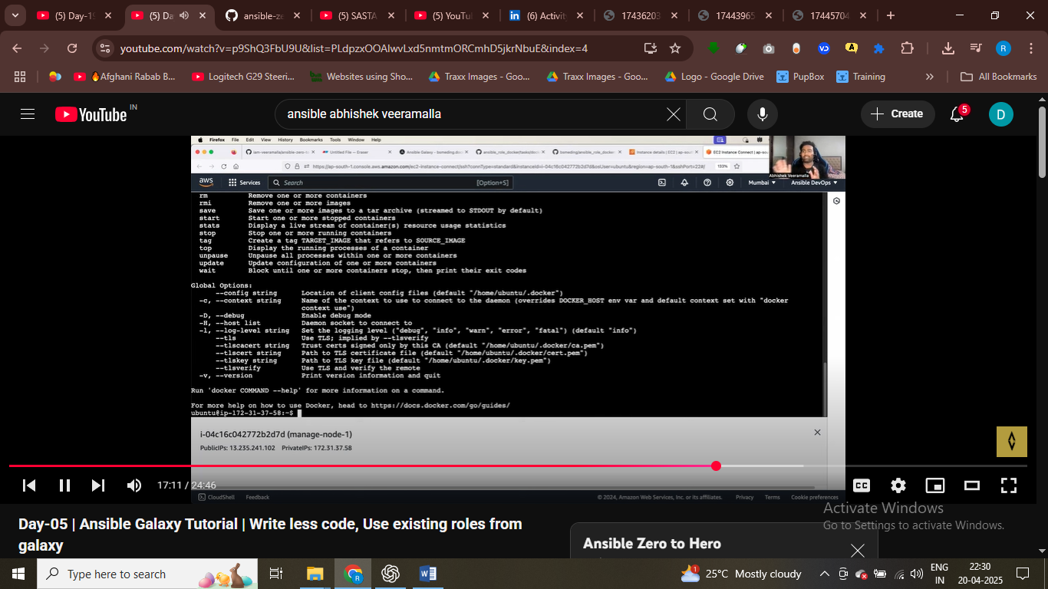

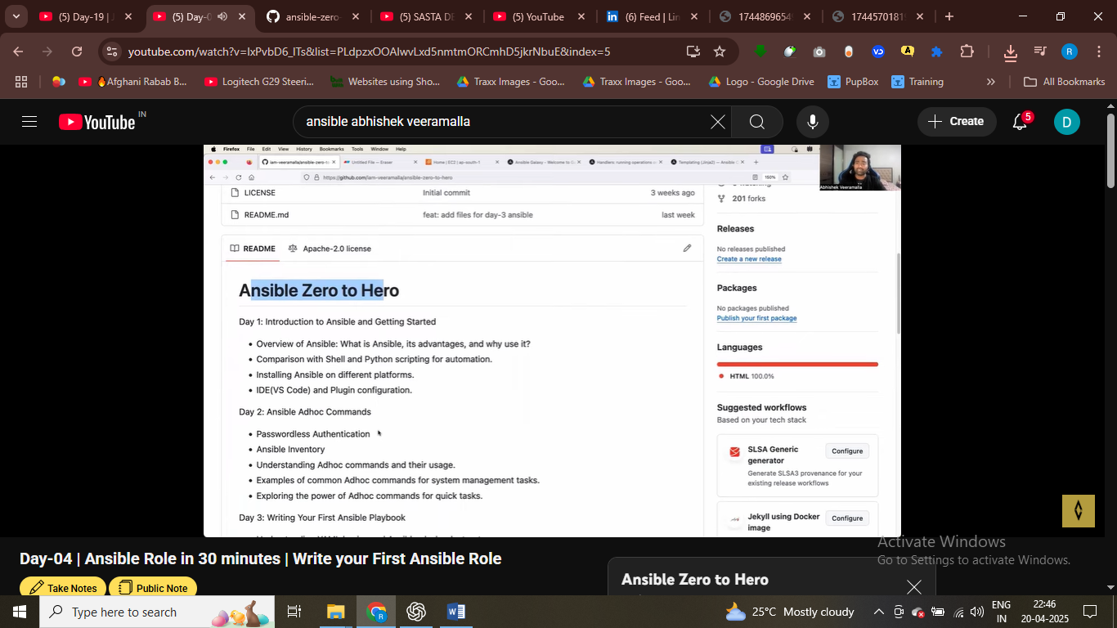

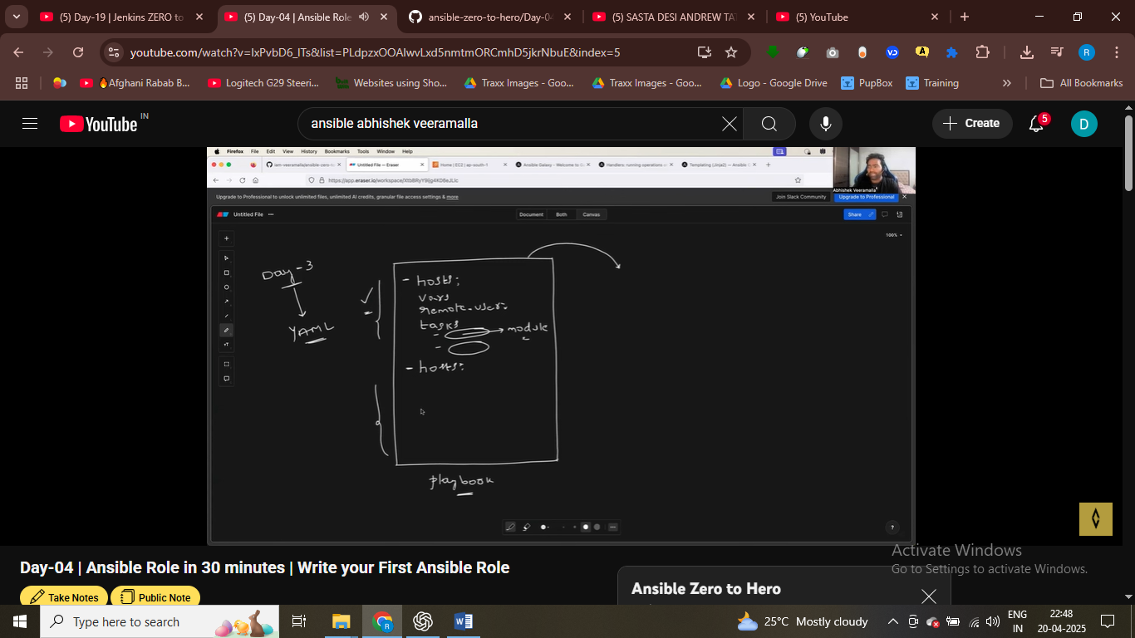

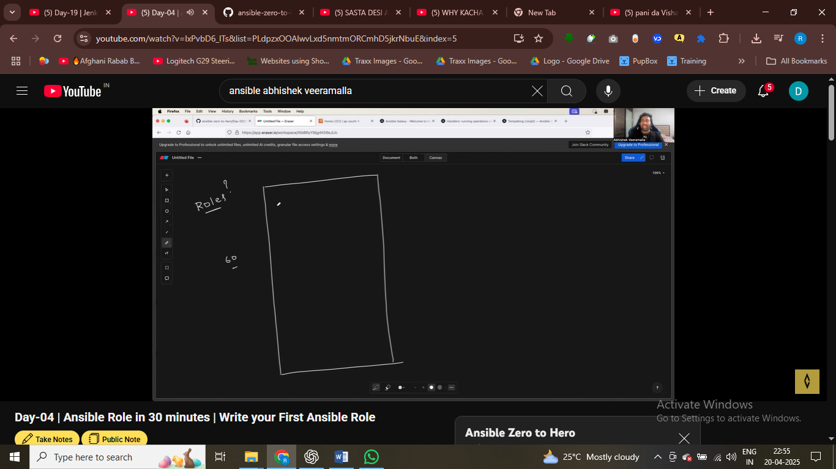#ansible playbboks has 60 varirables

Crate folder for tasks , varibales , roles make it readiiblity and modularity

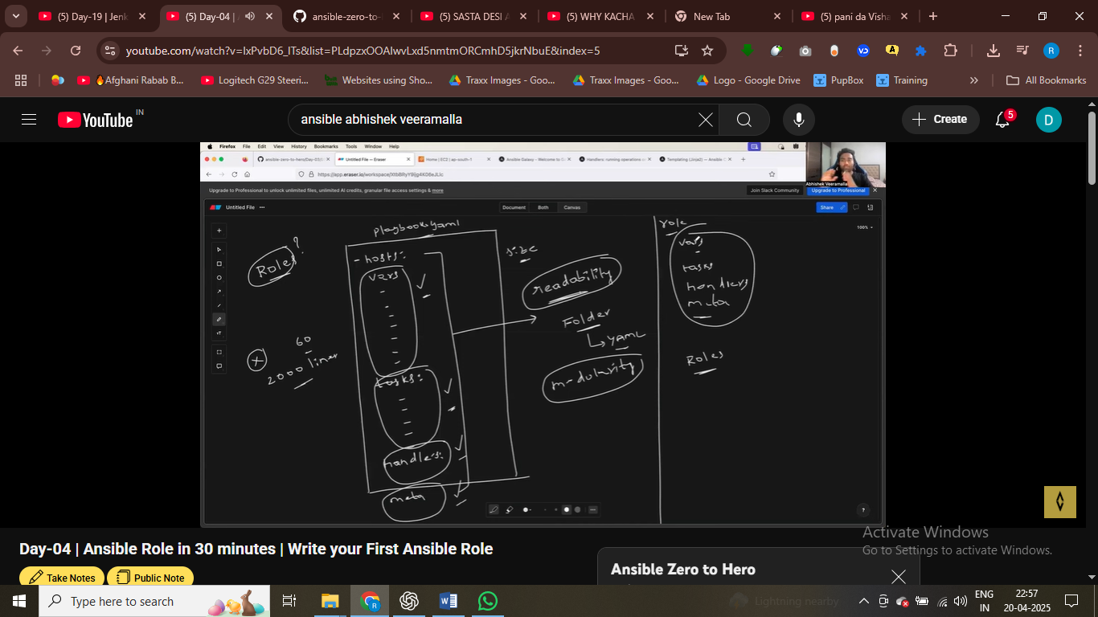

Split the ansible playbook based on tasks variable , and palced them in one umberally called roels

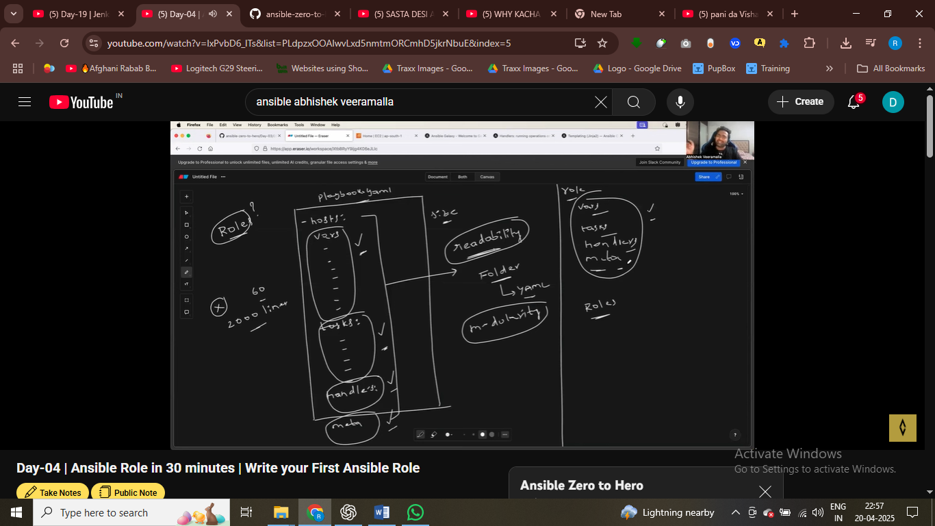

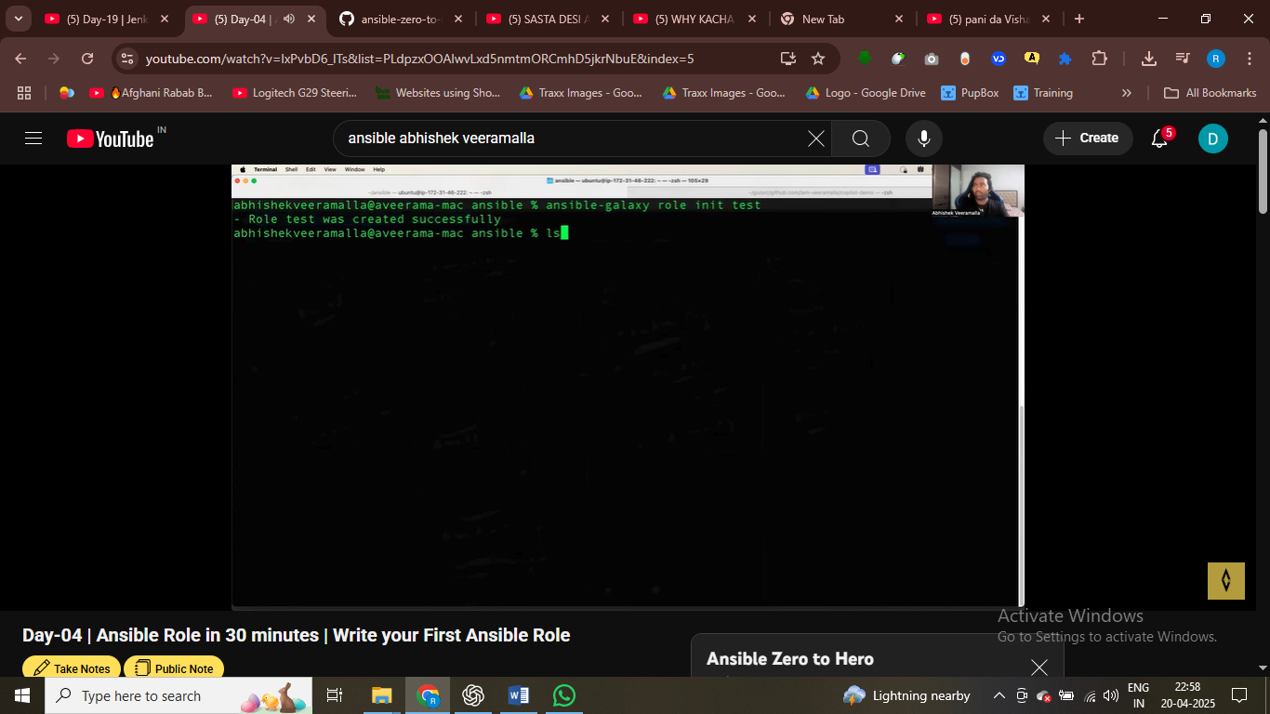creating a role using ansible galalxy

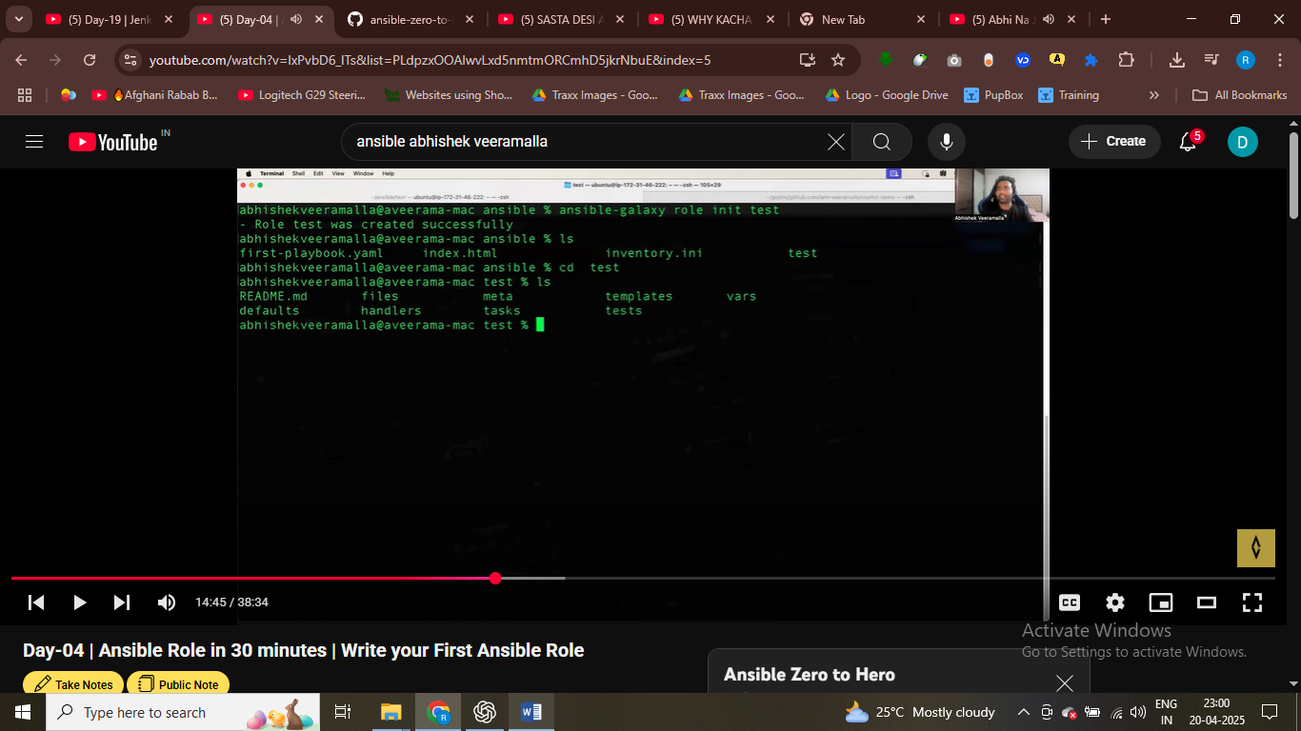inside roles we have these folders

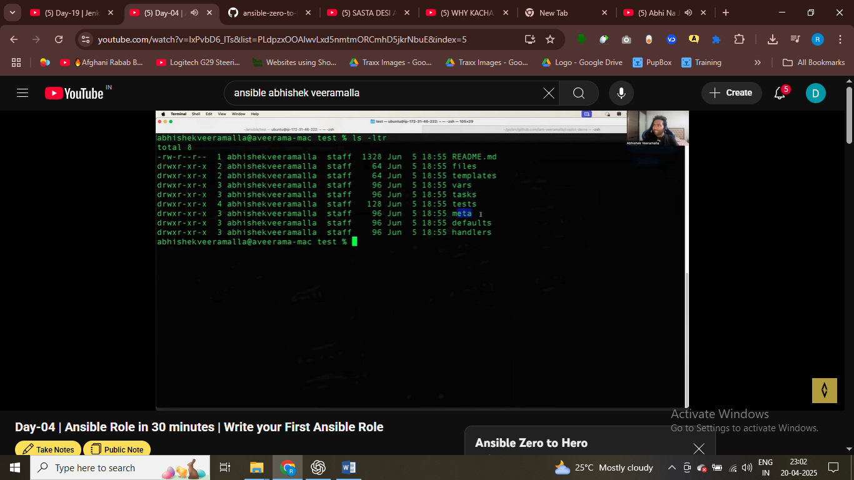roles container files vars handler templates

For simple playbook don’t use roles , but for large playbooks , complicate ansible playbooks

Installing and configuring kuberntes , on control nodes and worker nodes

Playbook go to 50 60 takss , isnteaqd use roles make playbook more readbale , more modular reusable

Roles can be shared across orgaz , using ansible galaxy , upl,oad your roles to ansible glalaxy4

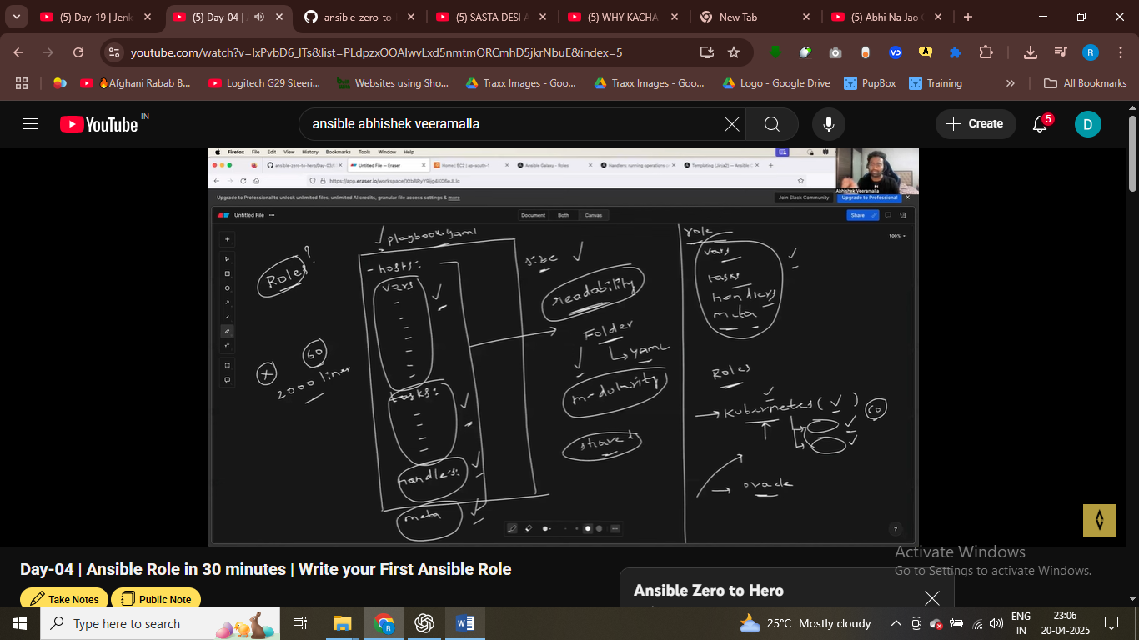role

Vars we have – container varibles here ,

Tasks –placed all your tsaks here 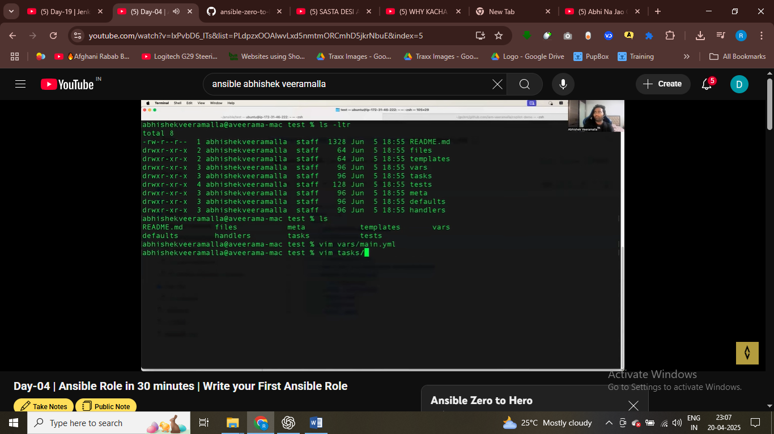

Meta here metadata we have

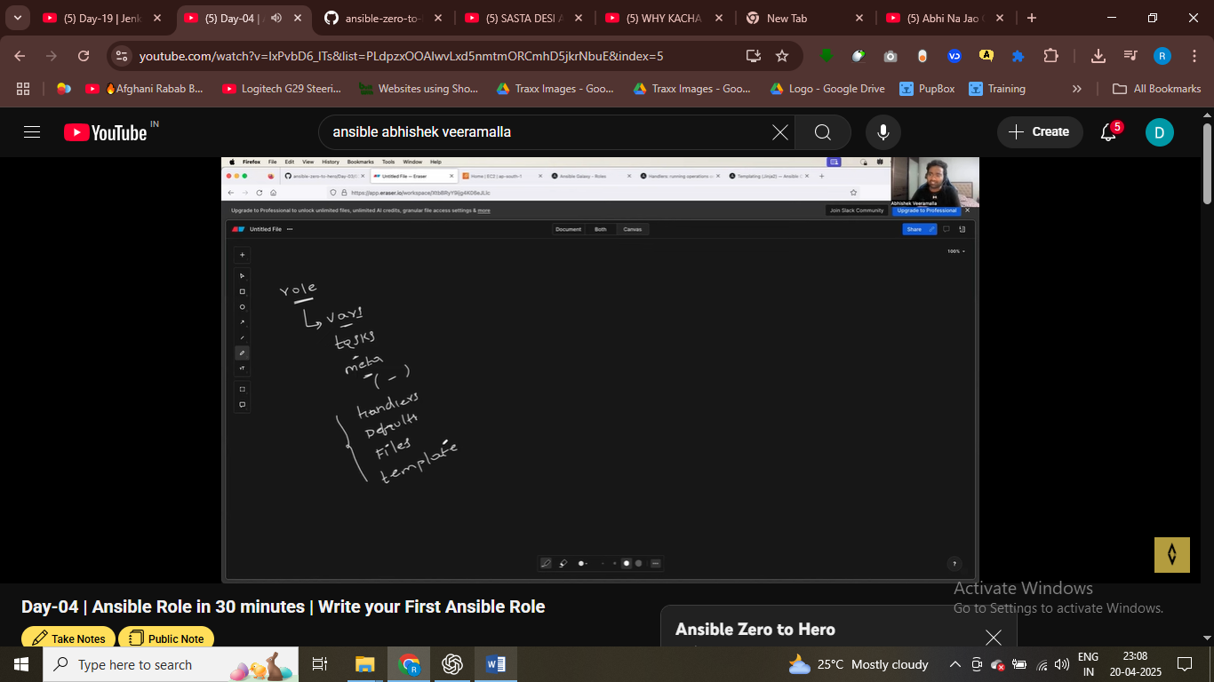we have multiple files like index.html put these files inside files directory

Teamplates use for dynamic files

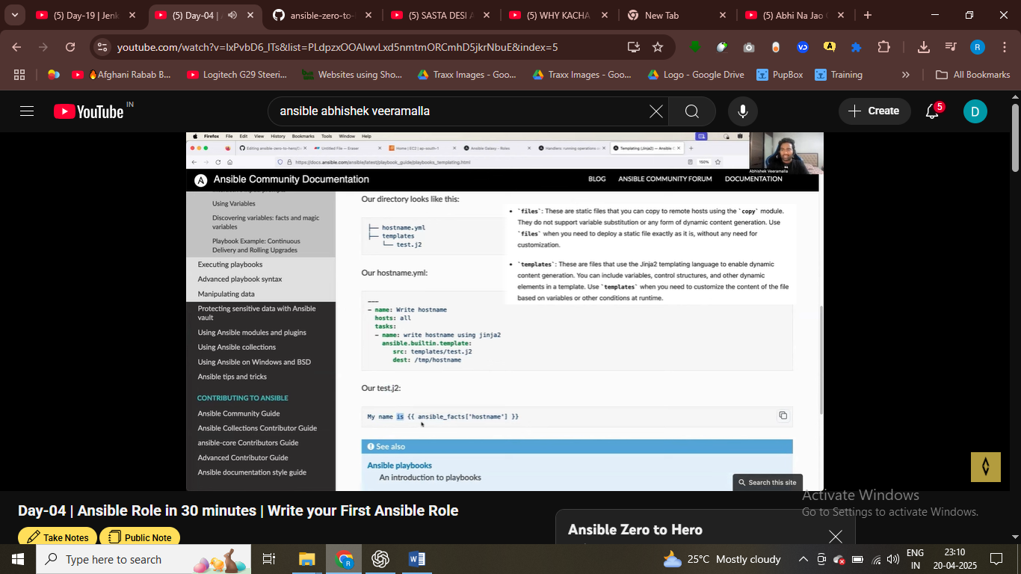

Defaults are varibles – default variable – don’t provide any value to variable use default variable

Handlers are tasks exectute on particular actions

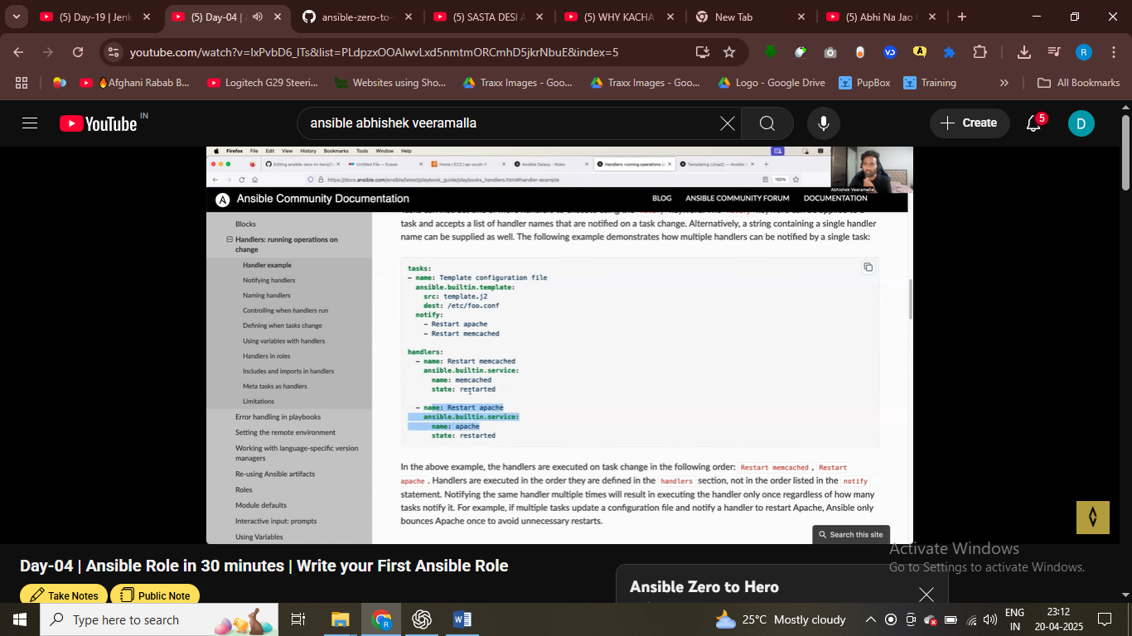handler is also like takss execute this task only particular task is running it

Restart webservere – we need to notify when handler need to be executed

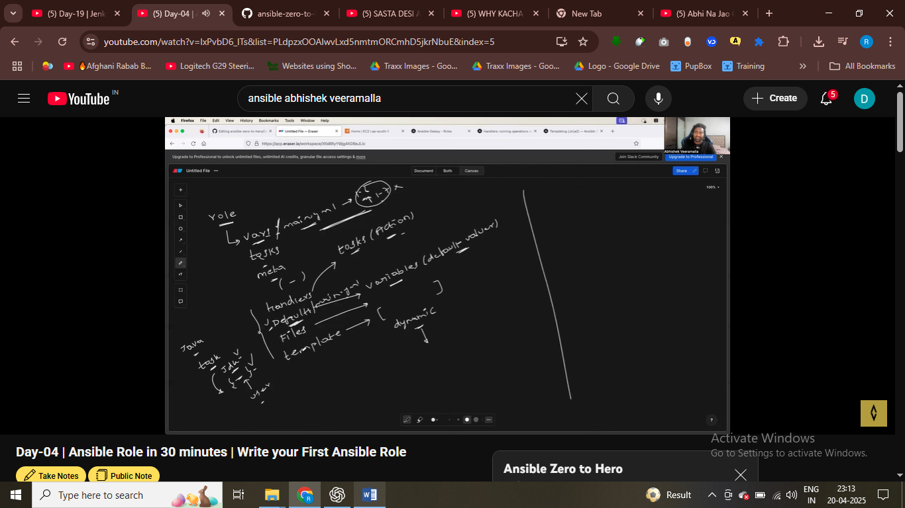

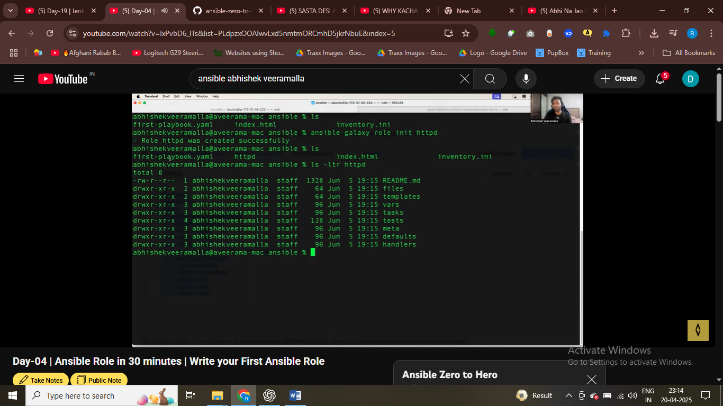

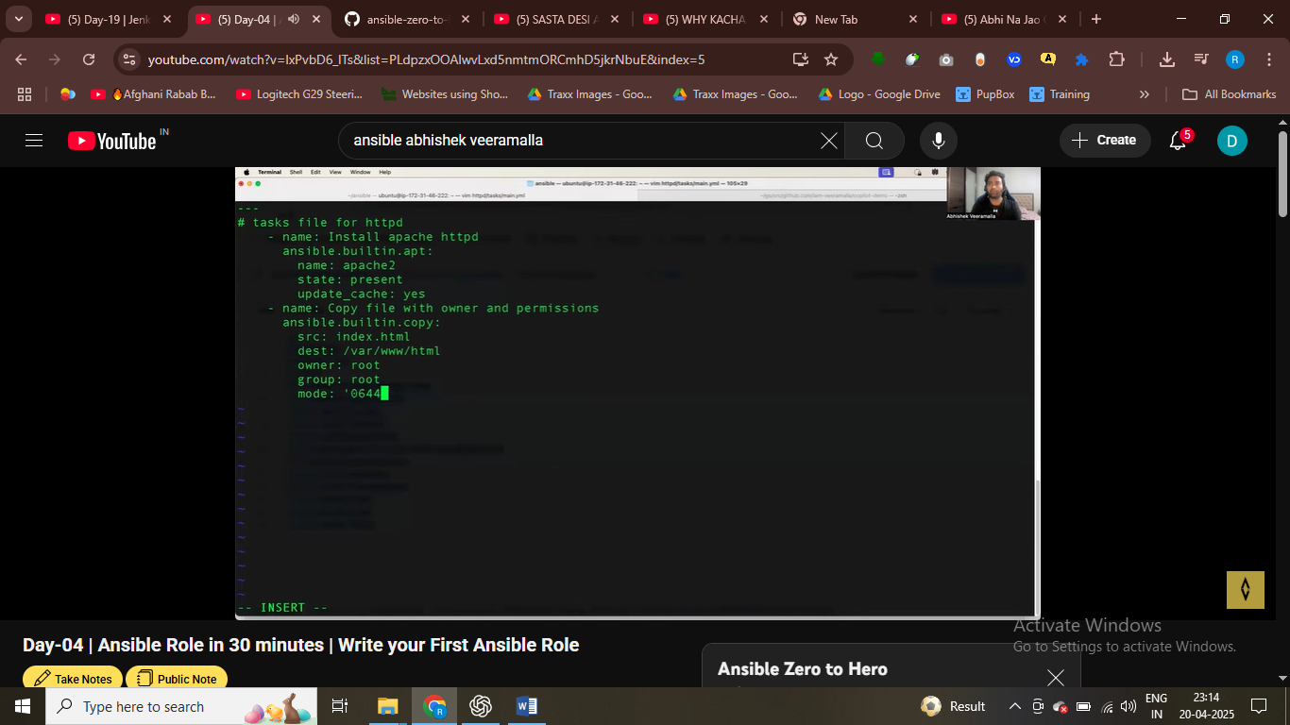

Here I am writing in takss that we crate role

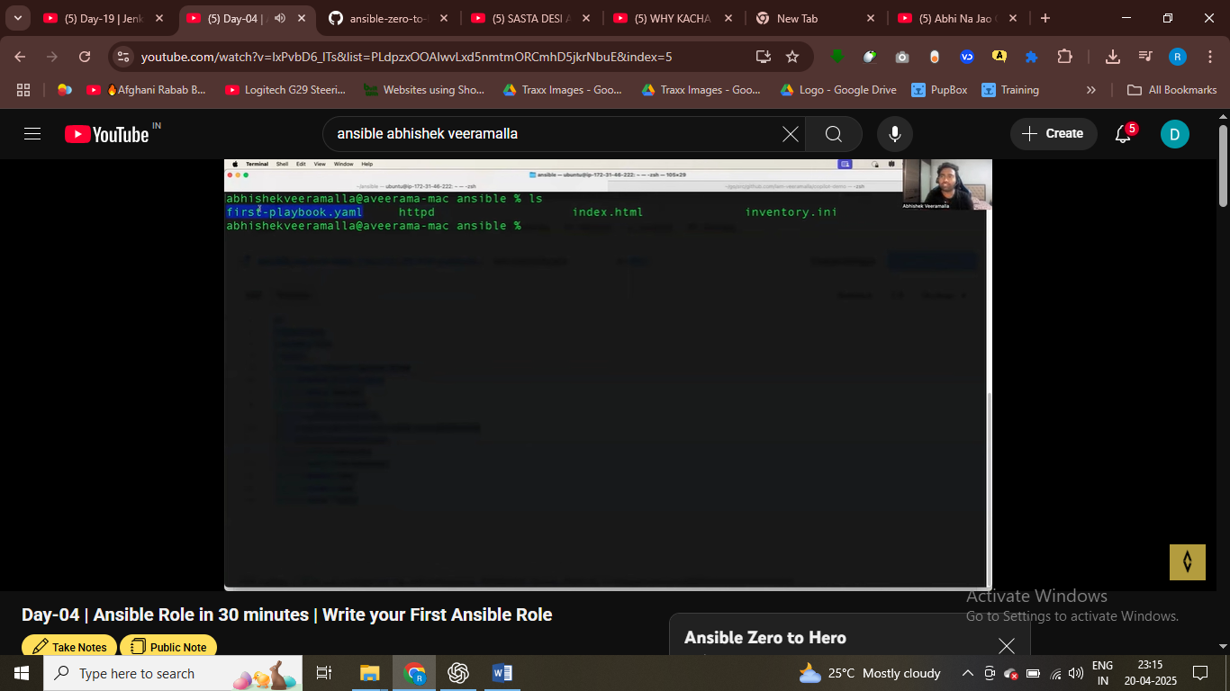remove the task from playbook and put in http role takss folder

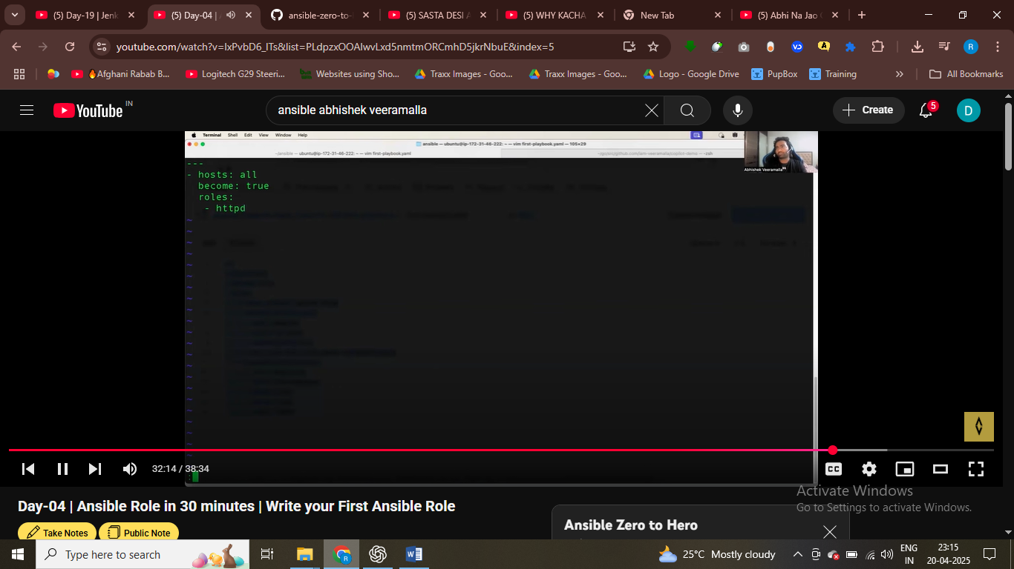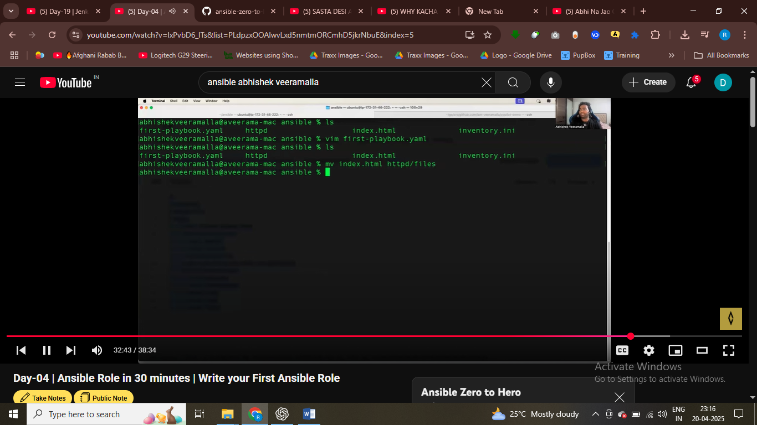

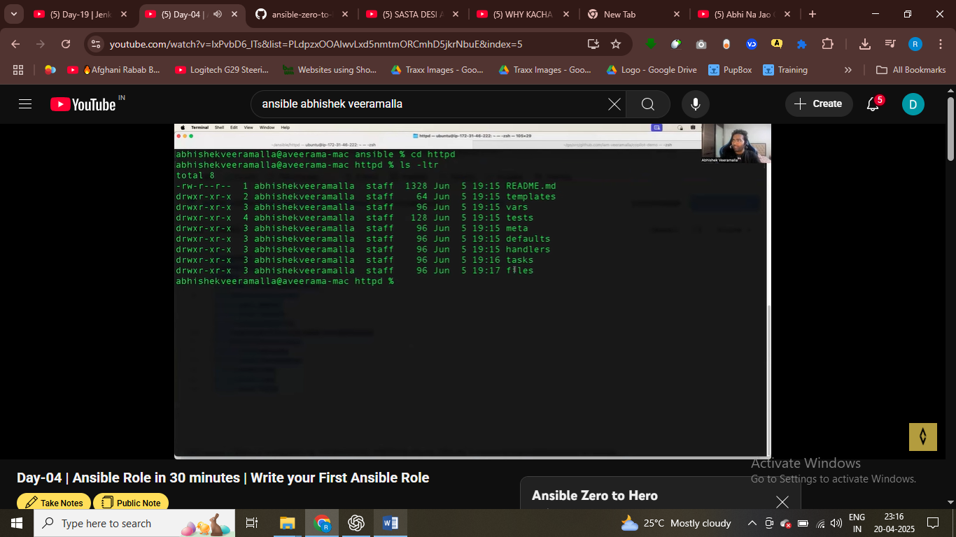roles just structre your code , modularize and resusable code

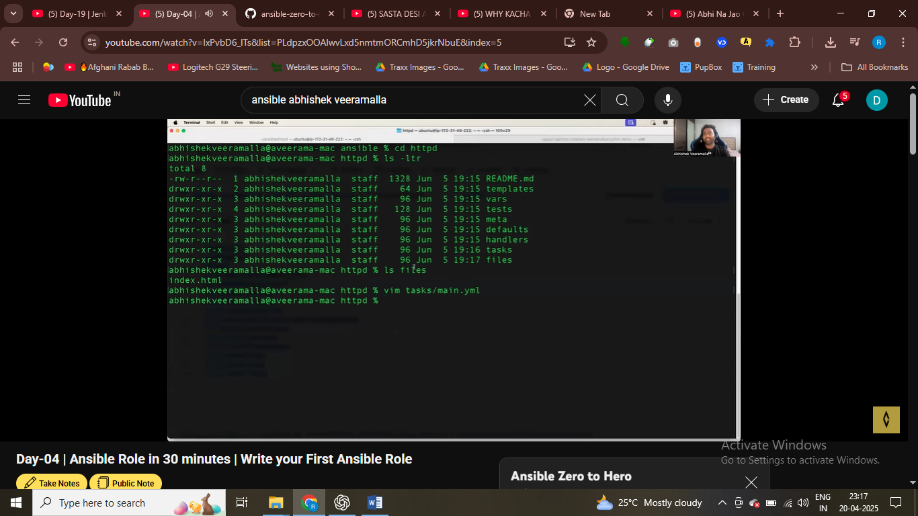

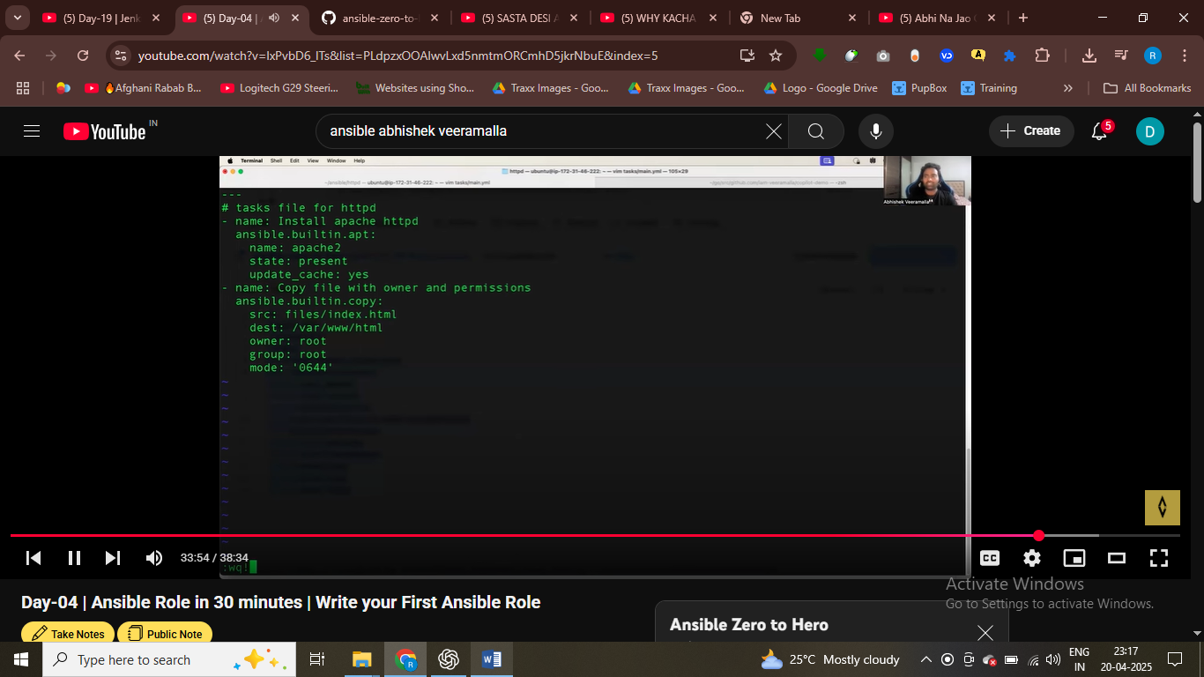

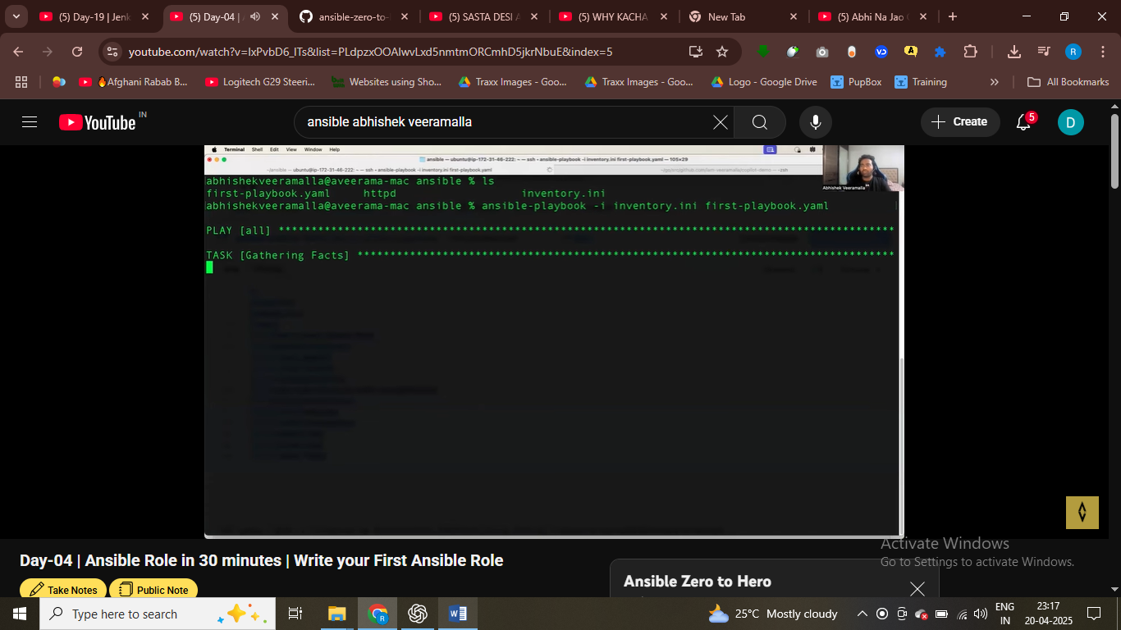gathering facts first task that will be execute via playbook , wheather target machine is reachebale , check for authentication and all

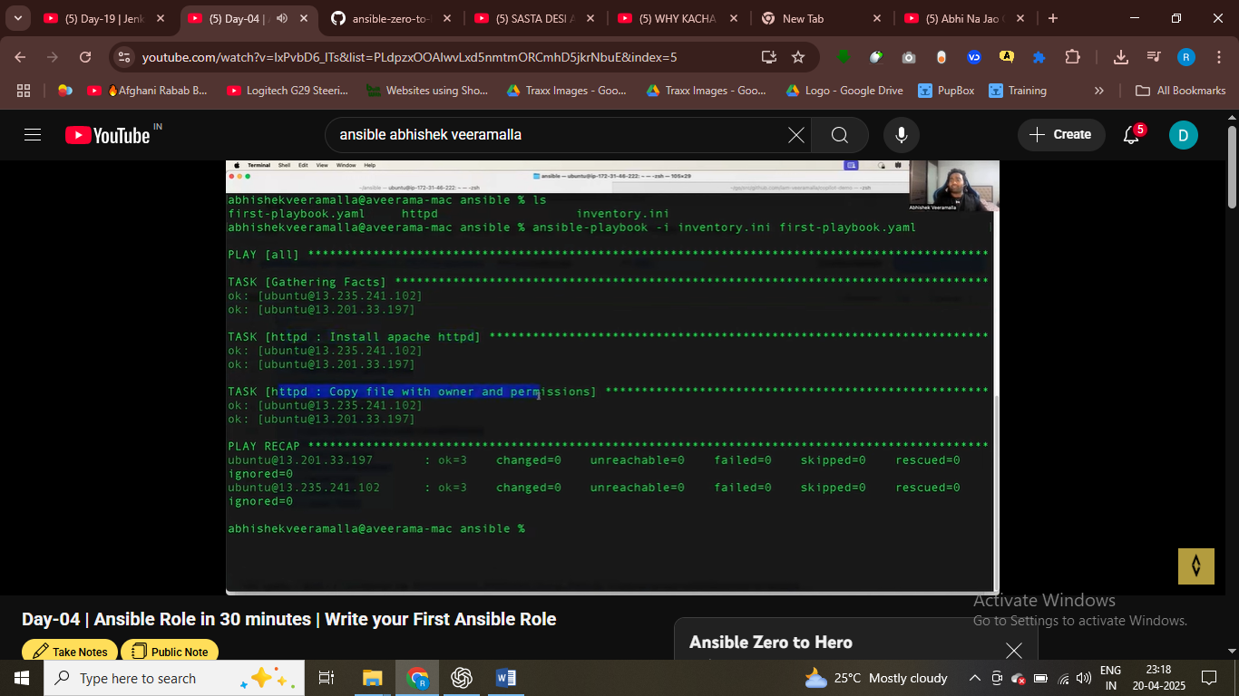

ANSIBLE INDEMOPOT4NETN I N NATURE –

* IF ALREADY present not create then it not crate antoher time
* Shell script is not idemetnpotent
* Ansbile will not crate the folder again, if it is already prenst – this nature is idemportent

